**Workify: Streamlining Senior High School Work Immersion**

**Management System with Data Analytics.**

A Capstone Project

Presented to the Faculty of

Our Lady of the Sacred Heart College of Guimba, Inc.

In Partial Fulfillment

of the Requirements of the Degree

Bachelor of Science in Information Technology

By:

CINENSE, Josh V.

NATIVIDAD, Michael Jan A.

NATIVIDAD, Miguel Von A.

REQUINA, Russel Edison C.

December 2024

**CHAPTER I**

**THE PROBLEM AND ITS BACKGROUND**

**Introduction**

Work immersion exposes senior high school students to real-world workplace settings where they can use their knowledge and earn experience relating to their selected tracks or specializations. This helps students enhance their work-related skills and knowledge. As stated by Ador et al, (2023), work immersion experience improved and equipped students for their professions. According to Gurobat et al, (2021), K to 12 Program in the Philippines aims to develop competencies and work ethic among learners, and work immersion has been found to enable students to acquire skills such as teamwork, communication, and professionalism.

Senior high school students explore professional interests through research and self-evaluation, and they participate in work immersion programs supervised by their professors and advisors. To acquaint oneself with the field in which they will be immersed, they attend seminars. Throughout the eighty (80) hours of the work immersion, students completed various duties that were delegated to them by the supervisors of the partner university (Acut et al, 2021).

However, limited options sometimes result in work immersion placements that do not align with students' interests. According to Insorio et al (2023) with student participants, a majority of them acknowledged a lack of prior knowledge or familiarity with the tasks and responsibilities assigned to them within their respective sectors during the Work Immersion course. As stated by Sidek et al, (2023), students may struggle to complete tasks efficiently and may lose interest in work immersion experiences that are unrelated to their intended college courses if there is a mismatch between their interests and the workplaces that are available.

The United Nations has established the Sustainable Development Goals (SDGs), consisting of 17 global development objectives. The mission of the SDGs, established in 2015, is to promote peace and prosperity for people and the planet, both now and in the future.

The study being conducted can be aligned with several SDGs, including SDG 4 (Quality Education) and SDG 17 (Partnerships for the Goals).

SDG 4 aims to ensure inclusive, equitable, and high-quality education for all, as well as promote lifelong learning opportunities. According to Cassar (2022), by streamlining the management system for senior high school work immersion, the study can contribute to enhancing the quality of education by improving the effectiveness of work-based learning experiences for students.

SDG 17 emphasizes the importance of partnerships and collaboration in achieving the SDGs. In the context of creating and implementing the streamlined management system, the study may involve cooperation between academic institutions, governmental organizations, and business partners (Vaghar, 2023). This highlights the significance of partnerships in attaining sustainable development goals.

Additionally, two more SDGs that could be relevant for the website streamlining the Senior High School Work Immersion Management System with Data Analytics are:

SDG 8 (Decent Work and Economic Growth): This goal focuses on promoting inclusive and sustainable economic growth, employment, and decent work for all. By leveraging data analytics in the management system, the project can contribute to aligning work immersion experiences with industry trends, thereby enhancing students' preparedness for successful careers and contributing to economic growth (Salahudin et al, 2023).

SDG 9 (Industry, Innovation, and Infrastructure): This goal aims to build resilient infrastructure, promote sustainable industrialization, and foster innovation. Implementing data analytics in the work immersion management system can facilitate the alignment of the curriculum with industry needs and trends, supporting the development of an innovative and dynamic workforce. This approach not only supports sustainable industrialization but also enhances the overall efficiency and effectiveness of work immersion programs, contributing to the development of a skilled workforce ready to tackle the challenges of the modern industrial landscape (Gera et al, 2023).

Therefore, integrating these additional SDGs into the project's framework can further enhance its contribution to sustainable development and create a comprehensive approach to streamlining the Senior High School Work Immersion Management System.

The goal of this project is to organize and simplify the work immersion program administration process. A work immersion management system can benefit students' employability, improve employment opportunities, and make a contribution towards achieving sustainable development goals (SDGs). As elaborated in the study of Pfeiffer et al, (2021), work immersion management systems have the potential to contribute to the achievement of the Sustainable Development Goals (SDGs) by addressing challenges related to awareness, motivation, information transfer, and education for sustainable behavior

To address these challenges, the proponents aim to create a project that specifically benefits senior high school students, making it easier for them to choose work placements compatible with their interests, tracks, and specializations. The primary objective of this project is to enhance the management of Senior High School (SHS) work immersion programs through the implementation of data analytics. By streamlining the system, the proponents aspire to provide administrators, educators, and students with a robust and user-friendly platform for data collection, integration, and analysis. This platform will facilitate data-driven decision-making, accurate matching of students with suitable work placements, standardized performance evaluation, and alignment of the curriculum with industry trends. Additionally, the project aims to incorporate feedback analysis and risk assessment to ensure a positive and impactful work immersion experience for students. Leveraging the transformative potential of data analytics, the proponents seek to revolutionize SHS work immersion management.

Furthermore, the proponents intend to create a comprehensive and dynamic work immersion management system by harnessing the power of data analytics. This system will promote efficiency, effectiveness, and continuous improvement. It will empower stakeholders to make informed decisions, optimize student placements, provide personalized feedback, and proactively address challenges. Ultimately, this system aims to enhance the overall educational journey and equip students with the necessary skills for successful careers.

The 21st century has brought about rapid changes in technology that have significantly impacted various aspects of society, including education. According to a journal titled “A Glimpse of the Past-and the Present” (2023), in the Philippines, the implementation of the K to 12 programs by the Department of Education aims to better prepare students for the demands of the modern workforce through an enhanced curriculum and the inclusion of work immersion. As stated by Amper (2022), as one of the required components of the senior high school curriculum, work immersion provides senior high school students with preparation for their future endeavors, including work, entrepreneurship, and higher education. However, managing the work immersion programs across different schools and industries remains challenging due to inefficient manual processes and a lack of data-driven decision making. (Dela Cruz et al, 2020).

This study recognizes the need to streamline work immersion management through a web-based portal that facilitates collaboration between schools and partner industries. According to Franco et al, (2022), by integrating relevant data from stakeholders, a digital solution has the potential to address current issues related to coordination, monitoring, and alignment with industry needs. A review of related literature reveals that data-driven strategies play a crucial role in enhancing customer experiences (Kim, 2023). As industries increasingly rely on digital platforms and social media for recruitment, an online portal aligns with these modern trends and provides a centralized hub for work immersion opportunities.

Under the K to 12 programs implemented in 2013 by the Department of Education, work immersion is a graduation requirement for senior high school students aimed at helping them apply classroom lessons to real work settings. According to Ann Ma., (2023) work immersion is needed to graduate in Senior High School (SHS) because it prepares students for college life and future careers. However, coordinating placements across multiple schools and industries remains challenging using existing manual processes. According to initial interviews with work immersion coordinators, common problems include inconsistent data collection from students and partner companies, difficulty monitoring student progress, and a lack of integration between systems.

Furthermore, as sectors swiftly embrace digital technology, the existing dependence on paper-based forms is increasingly incongruent with recruitment trends. Research indicates that social media has become a primary avenue for companies to recruit and employ students (Singh, 2023). To resolve these challenges, cultivate industry-relevant abilities in students, and enhance their preparedness for future employment, it is essential to optimize work immersion management via a centralized online site. Workify is a platform created by its proponents to assist senior high school students in locating appropriate employment opportunities within their specific academic strands, allowing them to gain insight into their prospective careers and experiences. Utilizing pertinent data and incorporating stakeholder input, this digital system might enhance procedures, align students with appropriate placements, and facilitate data-informed decision-making.

**Statement of the Objectives**

This study primarily aims to develop a Workify: Streamlining Senior High School Work Immersion Management System with Data Analytics.

Specially, it aimed to:

1. Assess the developed system/device based on the quality characteristics outlined in ISO 25010:

1. Functionality;
2. Reliability;
3. Usability;
4. Efficiency;
5. Maintainability;
6. Portability;
7. Security;
8. Compatibility;

2. Evaluate the developed system based on the following construct of the Technology Acceptance Model (TAM):

1. External
2. Perceived Usefulness;
3. Perceived Ease of Use;
4. Attitude Towards Using;
5. Behavioral Intention to Use;
6. Actual Use;

**Developmental Framework**

According to Altvater**,** (2023), SDLC or the Software Development Life Cycle is a process that produces software with the highest quality and lowest cost in the shortest time possible. SDLC provides a well-structured flow of phases that help an organization to quickly produce high-quality software which is well-tested and ready for production use.

To create the system, the proponents will follow the scrum methodology as a software development lifecycle, which consists of several phases. Scrum is an Agile methodology and framework for managing and completing complex projects. These phases can vary depending on the specific project requirements and design.

The following are the phases of the Workify: Streamlining Senior High School Work Immersion with Data Analytics.

**Planning.** In this phase, the proponents gather the project requirements, brainstorm ideas, and define the scope of the work immersion management system. As stated by Gordon et al, (2011) by gathering project requirements, proponents can ensure that they have a clear understanding of what needs to be achieved and can align their efforts accordingly.

**Design.** In the design phase, the proponents create the system’s architecture, user interface, and database structure. They will focus on creating a user-friendly dashboard for monitoring progress and making data-driven decisions. In the study of Tang et al, (2022) a well-designed dashboard enables decision-makers to make better decisions, expedite procedures, and improve student learning support. The design will incorporate visual representations of key metrics and performance indicators.

**Development.** This phase involves the actual coding and implementation of the system. The proponents will utilize programming languages, frameworks, and technologies suitable for web application development. Database management systems will be used for data storage, and data analytics tools will enable analysis and insights generation. (Byung-Kwon, 2003).

**Testing and Feedback.** Throughout the development process, the proponents will conduct continuous testing to ensure the system's functionality, performance, and security. According to an article entitled “Analyzing the effectiveness of different testing techniques in ensuring software quality”, (2023) various testing techniques, such as unit testing, integration testing, and user acceptance testing, will be employed to identify and resolve any issues or bugs.

**Iterative Improvements.** Agile methodology promotes continuous improvement. After the initial deployment, the proponents will gather feedback from stakeholders and analyze data from the work immersion program. This feedback and data analysis will guide us in making iterative improvements to the system, enhancing its effectiveness, and addressing any emerging needs or challenges. As stated by Yadav et al, (2017), organizations can identify areas for improvement, develop and implement change interventions, and track the impact of these interventions by analyzing feedback and data.

**Deployment.** Once the system has undergone thorough testing and quality assurance, it will be deployed to a production environment. This phase includes setting up the necessary infrastructure, configuring servers, and ensuring a smooth transition from development to production. (Florist, 2023).

Figure 1 Shows the Scrum Method, the Developmental Framework of the Proposed System.



**Figure 1: The Scrum Method**

**Technology Acceptance Model**

In the study of Ahmed et al, (2023), the Technology Acceptance Model (TAM) is a framework used to evaluate the acceptance and adoption of new technologies. It integrates usability and learning objectives to assess the impact of adopting virtual laboratories on student performance. The benefit of the Technology Acceptance Model (TAM) is that it provides valuable insights into the determinants of user acceptance of various technological applications and offers practical guidance for improving user experiences and outcomes.

Here are the factors that TAM integrates to evaluate user acceptance:

**External.** External variables in the Technology Acceptance Model (TAM) include factors such as motivation, content quality, trust, social influence, age, education level, computer self-efficacy, and web skills. These external variables play a crucial role in influencing users' acceptance and adoption of technology. (Rydhan et al, 2023).

**Perceived Usefulness.** It is a key factor in the Technology Acceptance Model (TAM) and has been studied in various contexts. The study of Solehatin (2023) showed that perceived usefulness has a significant impact on users' attitudes and intentions to use technology-based training programs. Studies have shown that when users perceive a training program as useful, they are more likely to have positive attitudes towards using it and a higher intention to actually use it. (Journal of Economics, Finance and Management Studies, 2023).

**Perceived Ease of Use.** It refers to the degree to which individuals believe that using a particular technology will be free from effort and easy to use. (Siregar, 2023). According to Ibrahim et al, (2022) the perceived ease of use of online learning platforms has been found to have a significant impact on the effectiveness of teaching professional education students.

**Attitude Towards Using.** An important factor that influences the intention to adopt certain strategies or applications. According to Liu et al, (2022) the attitude significantly influences the intention to use immersive technologies (ImTs) in the construction industry.

**Behavioral Intention to Use.** Behavioral intention to use in the Technology Acceptance Model (TAM) refers to an individual's intention or willingness to adopt and use a particular technology. It is a key construct in TAM that predicts the likelihood of actual technology usage. Several factors influence behavioral intention, including perceived usefulness, perceived ease of use, attitude, and self-efficacy. (Alzahrani, 2022).

**Actual Use.** Refers to the real usage of a system by its intended users. It measures the extent to which individuals actually use a system in their daily activities. The TAM suggests that intention to use and perceived usefulness lead to actual system usage. (Rahmana & Indriani, 2022)

Figure 2 Shows the Technology Acceptance Model (TAM), to Tell Whether the System/Application Was Accepted and Can Be Used by the Users.

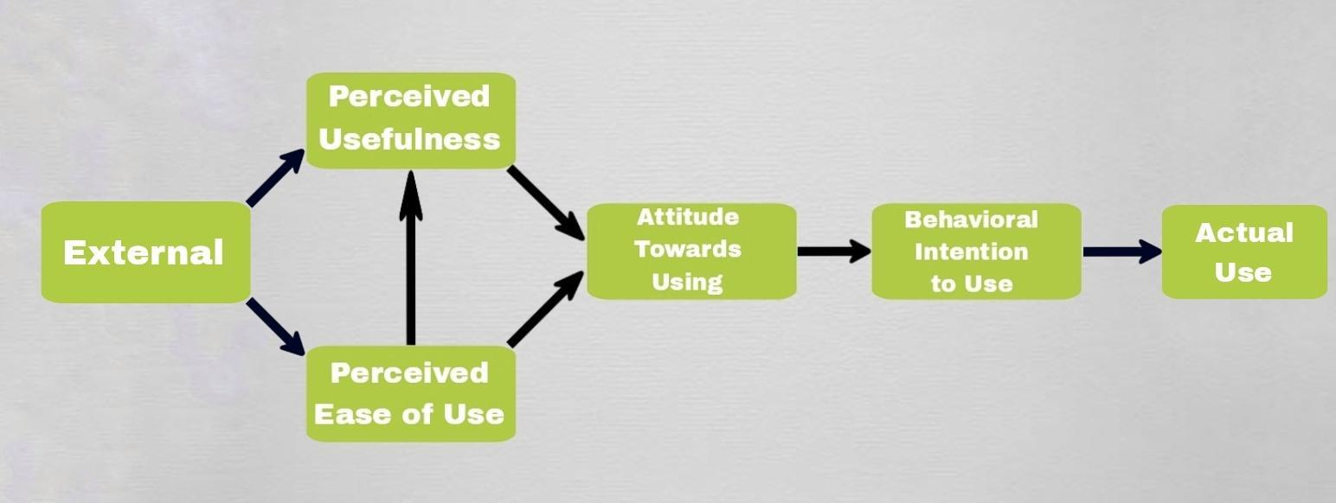

**Figure 2: Technology Acceptance Model (TAM)**

**Significance of the Study**

This study is significant to the following:

**Senior High School Students.** The system helps senior high school students get better placements when it comes to work immersion, get personalized support, and gain valuable industry insights; which will help them prepare themselves after they graduate.

**Teachers.** By automating the work immersion management system, it will be easier for teachers to reduce their time and work in finding suitable workplaces for their students, and it will also be a great help for their reports.

**Principal.** By automating the work immersion management system, it will be of great benefit to the school principal because they will be able to provide a better program to their senior high school students, and the quality of the school will be improved.

**Schools.** This system will help schools streamline work immersion programs, make data-based decisions easier, and collaborate better with partners, leading to improved learning, engagement, and career readiness for their students.

**Partner Organizations/Company.** Partner organizations benefit from the system by having access to a streamlined process for finding qualified student interns, receiving valuable feedback on their training programs, and building stronger relationships with schools.

**Proponents.** This study will benefit proponents by allowing them to expand their knowledge and learn new skills, techniques, and methodologies they can use in their future professions. This study also aims to prepare proponents to advance in their careers through their expertise and resourcefulness.

**Future Proponents.** This study can be used by future proponents as their basis for related studies.

**Scope and Delimitation**

Workify is an online digital service or website that can be accessed by users and administrators. Its purpose is to assist schools in choosing workplaces to be able to take action in case of negative performance that can be done by both parties that are more suitable and aligned with the needs of their senior high school students. The admin is in charge of monitoring, organizing necessary requirements, gathering student data, matching up students with suitable employers, and monitoring and evaluating the functionality of the website. The programming languages used to make the website are PHP, HTML, CSS, and JavaScript. PHP is used to process form data submitted by users. HTML, the most used programming language in websites and webpages. CSS helps design the website with many different styles for it to look presentable and professional. Lastly, JavaScript is a programming language that is primarily used for client-side scripting, it enables developers to respond to user actions on a web page.

To ensure a smooth and user-friendly experience, it will need database management systems for storing data, data analytics tools for analysis, and user interface design.

In order to keep trespassers out, this website was made exclusively for the chosen schools.

These are the attributes and capabilities of Workify: Streamlining Senior High School Work Immersion Management System with Data Analytics:

**Data Collection and Integration.** Establish a system that is capable of gathering and combining information from multiple sources, including industry partners, student profiles, and work immersion activities. This data can include student information, performance evaluations, feedback, and industry-specific metrics.

**Dashboard and Reporting.** Develop a user-friendly dashboard that provides visual representations of key metrics and performance indicators. This allows administrators, educators, and students to monitor progress, identify trends, and make data-driven decisions. Reports can be generated to provide comprehensive insights and analysis.

**Matching and Placement.** Utilize data analytics to optimize the process of matching students with suitable work immersion placements. Analyze student profiles, industry requirements, and performance history to identify the best fit and increase the chances of successful immersion experiences.

**Performance Evaluation.** To assess the performance of students during work immersion, a standardized evaluation system that uses data analytics is required. This may include defining evaluation criteria, collecting data from industry, and generating performance reports. Analytics can help with personalized student feedback and identify areas that need improvement.

**Identifying Industry Trends.** Analyze data from the work immersion program to identify emerging industry trends, skill requirements, and demands. This information can help educators and administrators align the SHS curriculum with current industry needs, ensuring that students receive relevant and up-to-date training.

**Feedback and Surveys.** Utilize data analytics to gather and examine input from a range of stakeholders, such as parents, industry partners, educators, and students. This can highlight areas for development, shed light on the program’s efficacy, and improve the whole experience.

**Risk Assessment and Intervention**. Use data analytics to identify potential risks or challenges during the work immersion program. By analyzing historical data and identifying patterns, administrators can proactively address issues and provide appropriate support or interventions to ensure a positive experience for students.

**Definition of Terms**

**Workify** - refers to the work immersion management system.

**Streamlining** - the practice of identifying and eliminating repetitive and unnecessary steps or activities in a process in order to make it more efficient and effective. (Kissflow, 2024).

**Data** - a collection of information gathered by analysis.

**Data Analytics** - is the science of analyzing raw data to make conclusions about information. (Frankenfield, 2023).

**Data-Driven Decision Making** - involves utilizing data to inform decision-making processes, improve services, identify trends, and enhance outcomes in various fields such as education and library services. (Donhost & Anfara, 2010)

**Database** - a structured collection of information or data that is often maintained electronically in a computer system. (Oracle, 2020).

**Work Immersion** - an educational program or activity that provides students with an opportunity to gain practical experience and exposure to real-world work environments related to their chosen field of study. (Yasmin, 2019).

**K-12 Program** - is an education system under the Department of Education that aims to enhance learners’ basic skills, produce more competent citizens, and prepare graduates for lifelong learning and employment. (K12Philippines, 2015).

**Stakeholders** - a person, group or organization with a vested interest, or stake, in the decision-making and activities of a business, organization or project. (Barney, 2023).

**Development** - refers to positive change or improvement.

**Technology** - deals with the creation and use of technical means and their interrelation with life, society, and the environment, drawing upon such subjects as industrial arts, engineering, applied science, and pure science. (Dictionary.com, 2019).

**Innovation** - systematic practice of developing and marketing breakthrough products and services for adoption by customers. (McKinsey, 2022).

**Software** - defined as a set of instructions, technically referred to as programs, that perform operations and specific tasks based on the commands of the user. (Simplilearn, 2022).

**Organization** - refers to a collection of people who are involved in pursuing defined objectives. (Business Jargons, 2017).

**Dashboard** - an information management tool that receives data from a linked database to provide data visualizations. (Adjust, n.d.).

**CHAPTER II**

**REVIEW OF RELATED LITERATURE AND STUDIES**

This chapter contains the discussion of other research and other related literature and related studies, from both local and foreign researchers. Which have significance on the research's variables. It focuses on aspects that could help the development of this study.

**Streamlined Management Systems in Education**

Streamlined management systems are essential for improving effectiveness and quality in educational institutions. According to Sethi et al, (2023), these systems centralized administrative processes, automate tasks, and facilitate access to data and information for informed decision making. Excellent decision making can have a big impact on academic performance and outcomes for students, instructors, and administrators. As stated by Duz (2023), the impact of data-based decision making on academic results is profound, leading to improved student outcomes and creating a more inclusive and engaging learning environment. The process not only boosts academic performance but also contributes to a decrease in discipline and attendance issues, highlighting the multifaceted benefits of data-based decision-making in education.

According to Verma (2022), Streamlined Management Information Systems in education enhance efficiency, increase profitability, and support staff in educational institutions, contributing to overall success in the sector.

It is important for educational institutions to have a streamlined system to provide a smooth way of carrying out and organizing the many tasks and responsibilities associated with the operation of the institution, an example for educational institutions that will benefit from a streamlined system is the work immersion for senior high school students. As stated by Insorio et al, (2023), work immersion is crucial for preparing students for college life and future careers.

**Benefits of Streamlined Management Systems for Learning Processes**

Wai-Sing (2018); Casey et al, (2021) stated that systems such as learning management systems (LMS) and online management systems, help in organizing, tracking, and delivering educational materials efficiently, leading to improved student performance and overall academic quality assurance. In addition, by integrating various components like program data records, assessment tasks, and learning goals, these systems ensure a comprehensive approach to managing learning processes. Additionally, the implementation of integrated learning systems has shown a significant positive influence on student learning achievements, with a notable impact on learning outcomes.

Therefore, the adoption of streamlined management systems not only facilitates online learning but also contributes to addressing challenges, enhancing the assessment process, and ultimately improving student learning experiences and outcomes.

**Impact Streamlined Management System on Student Experiences**

As stated by Patero (2023) a streamlined management system improves student experiences by enabling online booking of experiments, providing access to experiment-related materials, and promoting a safer environment through real-time monitoring of safety protocols. Moreover, efficient laboratory management contributes to improved pedagogy, as instructors can focus on teaching and guidance rather than administrative tasks.

**Workplace Skills and Competencies: An Industry Partners Appraisal on Work Immersion Program Among Senior High School Learners.**

According to Dela Cruz et al, (2020) the work immersion is to provide learners with real-world workplace experience, enhancing their skills and employability. The school collects the data from partner industry immersion supervisors who oversee the program. Results showed learners have high self-perceived work potency, confidence in managing assignments, and competence in communication and interpersonal skills. Exposure to job assignments teaches valuable life lessons and virtues.

Meanwhile, work immersion is somewhat like internships or on-the-job training done by college students. They have things in common, like letting students understand and experience actual work in a particular workplace. On the other hand, they differ in some loads and the number of hours they will consume. Therefore, most of the following studies discuss on-the-job training.

**Website-based High School Management Information System.**

According to Dewantara et al, (2019) technology development improves school quality, particularly in value management. Many schools still struggle with manual data storage and management. We created a website-based information system to improve data management, specifically focusing on student value information. Tests, analysis, and progress evaluations have successfully implemented this application, thereby improving the school's working quality.

According to Garcia et al, (2020) website-based work immersion program to analyze the performance, alignment, and employability of senior high school. The results showed that the students met the minimum job requirements set by partner institutions. The program was highly effective in terms of work readiness, skill usage, employment status, track alignment, waiting time, and salary. Students with higher personal skills, technical skills, and work applicability were more employable. The study suggests that academic institutions should continuously seek industries that will enhance students' skills to prepare them for future job opportunities.

**Data Analytics in Education**

According to Soncin and Cannistrà (2021) explored data analytics in educational management, focusing on potential to improve decision-making processes and enhance student outcomes. They emphasized the need for educational institutions to adapt to the digital age by leveraging data analytics tools.

Datafication nowadays is shaping different sectors because of the increasing number of automated systems, which store data from different sources (Jarke and Breiter, 2019). The education sector is one of the most noticeable domains affected by datafication, given the underlying potential of data for supporting effective teaching and learning and for transforming the ways in which future generations construct reality with and through data (Namoun and Alshanqiti, 2021; Jarke and Breiter, 2019). Leveraging on the increasing amount of data available, schools have started to deal with analytics (Li and Zhai, 2018) as a possible way to ensure greater quality and improve efficiency and inclusiveness, as crucial goals of any educational institution (Gaftandzhieva et al., 2021).

According to Brown (2017) outlined the benefits of using data analytics in managing Senior High School Work Immersion programs, including improved efficiency in student placement, better monitoring of student progress, and enhanced decision-making based on data-driven insights. According to Lee et al, (2022), the Singapore Education Ministry successfully implemented data analytics in managing work experience programs, leading to improved student outcomes and program efficiency.

**Work Immersion performance**

Streamline management systems have matching and placement utilize data analytics to optimize the process of matching students with suitable work immersion placements. Analyze student profiles, industry requirements, and performance history to identify the best fit and increase the chances of successful immersion experiences. According to Arceta (2023) the 325 immersion students who engaged from the partner industries were assessed in the aspects of work habits, work skills, and social skills. Also, the system will have a performance evaluation by providing an online survey questionnaire to the student, which will reveal the alignment and employability of the immersion program.

According to Manayan (2022) the students are independent enough to render their working progress to maintain their job performance and satisfaction, despite industry experts successfully rendering their technical assistance. The streamline management system will visualize for students the identification of industry trends for industry immersion. School administrators have to strengthen communication with industry partners in order to figure out the current trends regarding industry demands and prepare the students to equip them with the necessary knowledge, skills and competence that suit the expectations of the industry.

According to Alcobendas, J. R. (2022) data revealed that student-trainees performed very satisfactorily on their work immersion showing good work ethics and personalities suitable for a future employee in any company they want to apply to. The streamline management system collects and integrates data from various sources such as student profiles, industry partners, and work immersion activities. The students have the same level of job skills which implies that the profile variables of the trainees have no influence on their work immersion performance.

According to Macalintal, I. L. and Chavez, C. M. D. (2020) using a streamline management system provide the study evaluated how well-prepared Grade 12 students were for work immersion in terms of timeliness, interpersonal interactions, efficiency, productivity, and safety. In order to demonstrate that students were ready for safety procedures, interpersonal interactions, and timeliness as well as the partner industry, a streamlined management system will furnish surveys and feedback to both the firm and the students. However, students will find it difficult to be productive and efficient. There were problems with coworkers who were unapproachable, a strict schedule, a superior attitude, and a laborious job. As per the study's findings, pupils require additional activities to develop into productive workers.

**Synthesis**

The study discusses the importance of streamlined management systems in education and data-based decision making. It emphasizes that these systems help in organizing, tracking, and delivering educational materials efficiently, leading to improved student performance and overall academic quality assurance. The integration of various components like program data records, assessment tasks, and learning goals ensures a comprehensive approach to managing learning processes. The implementation of integrated learning systems has shown a significant positive influence on student learning achievements, with a notable impact on learning outcomes. Additionally, streamlined management systems contribute to addressing challenges, enhancing the assessment process, and ultimately improving student learning experiences and outcomes. Data-based decision making is highlighted as having a profound impact on academic results, leading to improved student outcomes and creating a more inclusive and engaging learning environment. It also boosts academic performance and contributes to a decrease in discipline and attendance issues, highlighting the multifaceted benefits of data-based decision-making in education.

**CHAPTER III**

**METHOD RESEARCH**

This chapter presents the research method and the process, technique, and process of gathering the needed data and information to complete and develop the Workify: Streamlining Senior High School Work Immersion Management System with Data Analytics.

**Method Research**

A quantitative research approach was used in this study to give proponents a wider understanding of how to improve Workify: Streamlining Senior High School Work Immersion Management System in Data Analytics. According to Little T. D. et al (2024), quantitative method focuses on the reliability and validity of data collection instruments, ensuring that the data accurately reflects the phenomena being studied

The quantitative method provides objective and robust information useful in making data-based decisions, deciding which interventions should be prioritized, and analyzing successfully implemented improvements using structured instruments such as surveys. According to York R. O. (2022), quantitative methods in mental health research offer reliable data for decision-making, prioritizing interventions, and evaluating implemented improvements through structured tools like surveys, enhancing policy effectiveness.

**Research Design**

Workify: Streamlining Senior High School Work Immersion Management System with Data Analytics will employ the descriptive-developmental design in order to concentrate on the system's advancement and enhancement. According to Lindsay, A. et al (2015), developmental design in systems, such as streamlining, aims to enhance efficiency and effectiveness in various domains. For instance, in product design, the concept of a product design streamline is proposed to minimize waiting time and waste, utilizing technologies like complex network theory and genetic algorithms.

The "Workify: Streamlining Senior High School Work Immersion Management System with Data Analytics" project is a good fit for the descriptive-developmental approach since it thoroughly examines the current system and emphasizes its continuous improvement.

**Research Locale**

To enhance and thoroughly analyze the Workify system from various perspectives, this research will be carried out in the Municipality of Guimba in Nueva Ecija.

The Municipality of Guimba is located in the province of Nueva Ecija, Philippines. It is divided into 64 barangays with an area of ​​245.29 square kilometers. According to the 2020 census, it has a population of 127,653 people. (n.d).

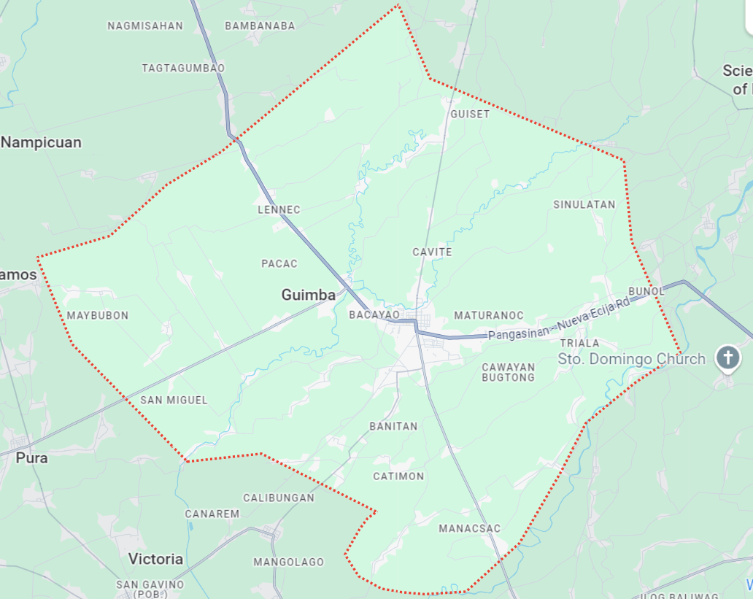

**Figure 3: Guimba, Nueva Ecija**

**The Respondents**

The total number of respondents that will be required in this study is 50. It consists of 20 IT professionals and 30 End-Users. Table 1 shows the frequency and percentage distribution of the respondents in terms of group classification.

Table 1. Frequency and Percentage Distribution of the Respondents in Terms of Group Classification.

|  |  |  |
| --- | --- | --- |
| Group Classification | Frequency | Percent |
| IT Professionals  *IT Instructors*  *IT Practitioners* | **20**  *10*  *10* | **40** |
| End-Users  *Students*  *Teachers*  *Training Supervisors* | **30**  *20*  *5*  *5* | **60** |
| TOTAL | **50** | **100** |

The ISO 25010 tool will be used by IT professionals due to their technical proficiency and familiarity with industry standards. As IT professionals, they are likely to have in-depth knowledge of various IT-related ISO standards, guidelines, and best practices. While End-users such as students, teachers, and training supervisors will utilize the TAM tool to gather important information on the acceptance of the Workify.

**The Instruments**

ISO 25010 is an international standard used for evaluating software quality (Al Rahmad et al, 2023). It provides a framework for assessing various attributes of software, such as functionality, performance efficiency, usability, and portability. Studies have applied ISO 25010 to assess the quality of different applications, including Learning Management Systems (LMS), VR applications for music learning, transportation services applications, reproductive health monitoring apps, and toddler nutritional status monitoring apps. By utilizing ISO 25010, researchers can identify strengths and weaknesses in software systems, make recommendations for improvement, and ensure that applications meet established quality standards. Overall, ISO 25010 serves as a valuable guideline for evaluating and enhancing the quality of various software applications across different domains.

A research instrument utilizing the Technology Acceptance Model (TAM) was developed and validated in various studies. In one study, an instrument was created to assess the performance of university lecturers, incorporating elements from the TAM model. Another study focused on digital natives' acceptance of interactive kiosks in museums, adapting TAM constructs like perceived usefulness and ease of use (Manan et al, 2022).

The proponents of this study utilize ISO 25010 which includes functionality, reliability, usability, efficiency, maintainability, portability, security, and compatibility. They will also use in this study the TAM or Technology Acceptance Model which consists of perceived usefulness, perceived ease of use, attitude towards using, and behavioral intention to use. The items in the questionnaire were evaluated on a five-point scale with the following descriptions: 5 - strongly agree, 4 - agree, 3 - neutral, 2 - disagree, and 1 - strongly disagree.

**Reliability Test Result**

Cronbach's alpha is a widely used metric for estimating scale reliability in various fields like psychology, mathematics education, and biomedical research. However, concerns exist regarding its limitations and potential inflation at common thresholds like 0.70, 0.80, and 0.90 (Zakariya, 2022).

Table 2. The Reliability Test Result

|  |  |  |  |
| --- | --- | --- | --- |
| Questionnaire | Cronbach’s Alpha | Interpretation | Item |
| TAM | 0.96 | Excellent | 18 |
| ISO 25010 | 0.91 | Excellent | 24 |

The table shows the reliability result based on Cronbach's alpha. The TAM questionnaire has 18 items and obtained a Cronbach's alpha result of 0.96, which is interpreted as excellent. Whereas the ISO 25010 questionnaire that was also used in the survey with 24 items got Cronbach's alpha result of 0.91 with the same interpretation as excellent.

A Cronbach's alpha of 0.70 is generally considered acceptable, while values above 0.90 are seen as excellent (Kilic, 2016). Therefore, Cronbach’s alpha result of 0.91 and 0.96 is considered excellent. According to Shahrestani, et al. (2016), an alpha of 0.96 suggests that the instrument is very reliable, as values above 0.90 are generally considered excellent.

According to Table 2 in this study, the results of overall raw alpha of 0.91 and 0.96 were obtained from the ISO 25010 and TAM questionnaires, which is considered to be extremely highly reliable and acceptable.

**Data Gathering Procedures and Techniques**

Two phases were involved in the study: Development and Assessment

1. **Development Phase**

The development phase is based on the scrum model. It has six phases, these are the following: planning, design, development, testing & feedback, iterative improvements, and deployment.

1. **Assessment Phase**

In this phase, Workify: Streamlining Senior High School Work Immersion Management System with Data Analytics will be subject to assessments by IT professionals and End-Users through surveys and interviews.

The collected data will be analyzed through data analytics to find out the system's weaknesses as well as potential solutions and improvements to its implementation.

The outcomes of the survey and interview, along with the proposals and advice received by the proponents, will be utilized to enhance the implementation of Workify.

**Analysis of Data**

The application assessment provided by the respondents was subjected to analysis and interpretation using the rubric to guide the scoring. The respondents' mean rating served as the basis for determining the created application's qualitative rating. Positive quality was indicated by a high mean rating for the quality factors, whereas negative characteristics were indicated by a low mean rating.

Table 3. Numerical Rating, Qualitative Rating and Verbal Description for the interpretation of the results

|  |  |  |
| --- | --- | --- |
| **Numerical Rating** | **Qualitative Rating** | **Verbal Description** |
| 4.20 – 5.00 | Excellent | The statement performs and has an excellent standard, surpassing expectations in the specified aspect. |
| 3.40 – 4.19 | Very Good | The statement meets expectations and demonstrates effectiveness in the specified aspect. |
| 2.60 – 3.39 | Good | It meets basic expectations in the specified aspect but lacks notable strengths or standout features. |
| 1.80 – 2.59 | Fair | It needs major improvements due to features with noticeable weaknesses in the specified aspect. |
| 1.00 – 1.79 | Poor | The statement has serious problems and weaknesses and fails to meet expectations in the specified aspect. |

**CHAPTER IV**

**PRESENTATION, ANALYSIS, AND INTERPRETATION OF DATA**

This chapter covers the development and analysis of Workify: Streamlining Senior High School Work Immersion with Data Analytics. Based on the survey conducted using the questionnaire by the proponents in Guimba, Nueva Ecija during the academic year 2024-2025.

The survey was conducted with the cooperation of IT professionals and end-users such as students, teachers, and training supervisors who assessed Workify: Streamlining Senior High School Work Immersion Management System with Data Analytics based on the TAM and ISO 25010.

**1.1 Product Backlog**

This phase involves structuring of the identified tasks and coming up with a guide that has to be followed in order to instantiate and nurture the system. It acts as working storage for all the user expectations and provides information to the development process in form of work items which are prioritized.

  As Buzhinskaya et al, (2022) mentioned, the process of creating the product backlog lists is also used in educational processes to train students – future IT specialists – in the context of developing collaborative software.

**1.1.1 Gantt Chart**

Gantt chart is an essential tool in project management with bar charts in which the bars represent activities in a process for execution over a specified time. This makes it easier to monitor and plan the project calendar using horizontal lines that serve as the duration of the project. The length of each bar corresponds to the duration of the task, allowing for a quick visual assessment of project timelines (Bianconi, 2024).

Figure 4 Shows the Schedule of Activities that the Proponents Underwent During the Development of Workify: Streamlining Senior High School Work Immersion with Data Analytics.

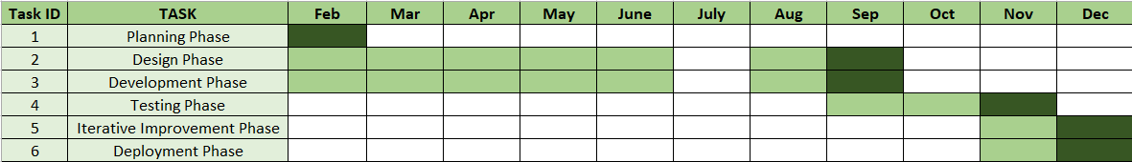

**Figure 4: Gantt Chart**

**1.1.2 Database Normalization**

Database normalization is a systematic approach to organizing data in a relational database to reduce redundancy and improve data integrity. The process typically involves decomposing a database into smaller, manageable tables while ensuring that relationships between the data are maintained. The normalization process is divided into several stages, commonly known as normal forms (1NF, 2NF, 3NF). Each stage addresses specific types of redundancy and anomalies, with 3NF being a widely accepted standard for a normalized database (Mendoza & Piedra, 2020).

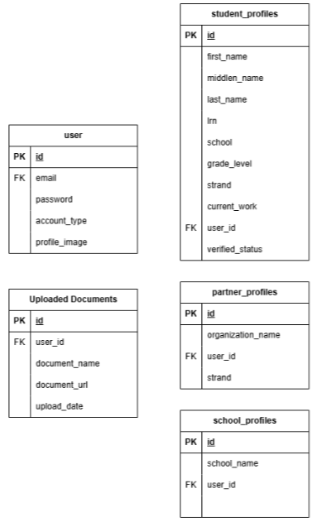

**Figure 5: First Normalization Form**

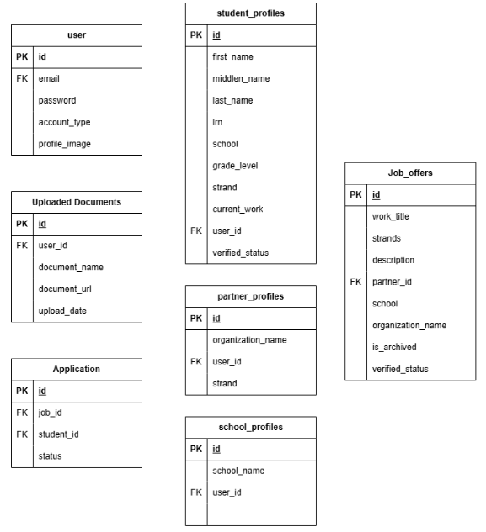

**Figure 6: Second Normalization Form**

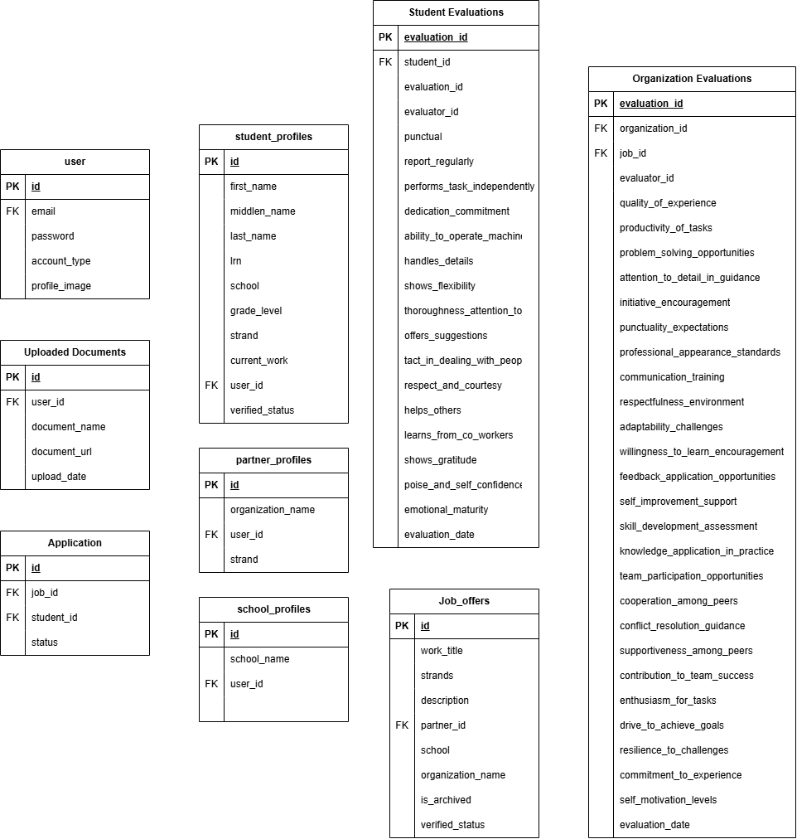

**Figure 7: Third Normalization Form**

**1.1.3 Entity Relationship Diagram**

An Entity Relationship Diagram (ERD) is a kind of flowchart that shows how certain entities, individuals, objects or concepts connect to one another within a system. ER Diagrams are used predominantly for creating or analyze relational databases in the sphere of software engineering, business IT systems, education, or research (LucidChart, 2017). According to Afiifah, et al (2022), they are crucial in the initial stages of database design, helping to outline user data requirements and ensuring that all entities are interconnected appropriately.

Figure 6 Shows the Entity Relationship Diagram of Workify: Streamlining Senior High School Work Immersion with Data Analytics.

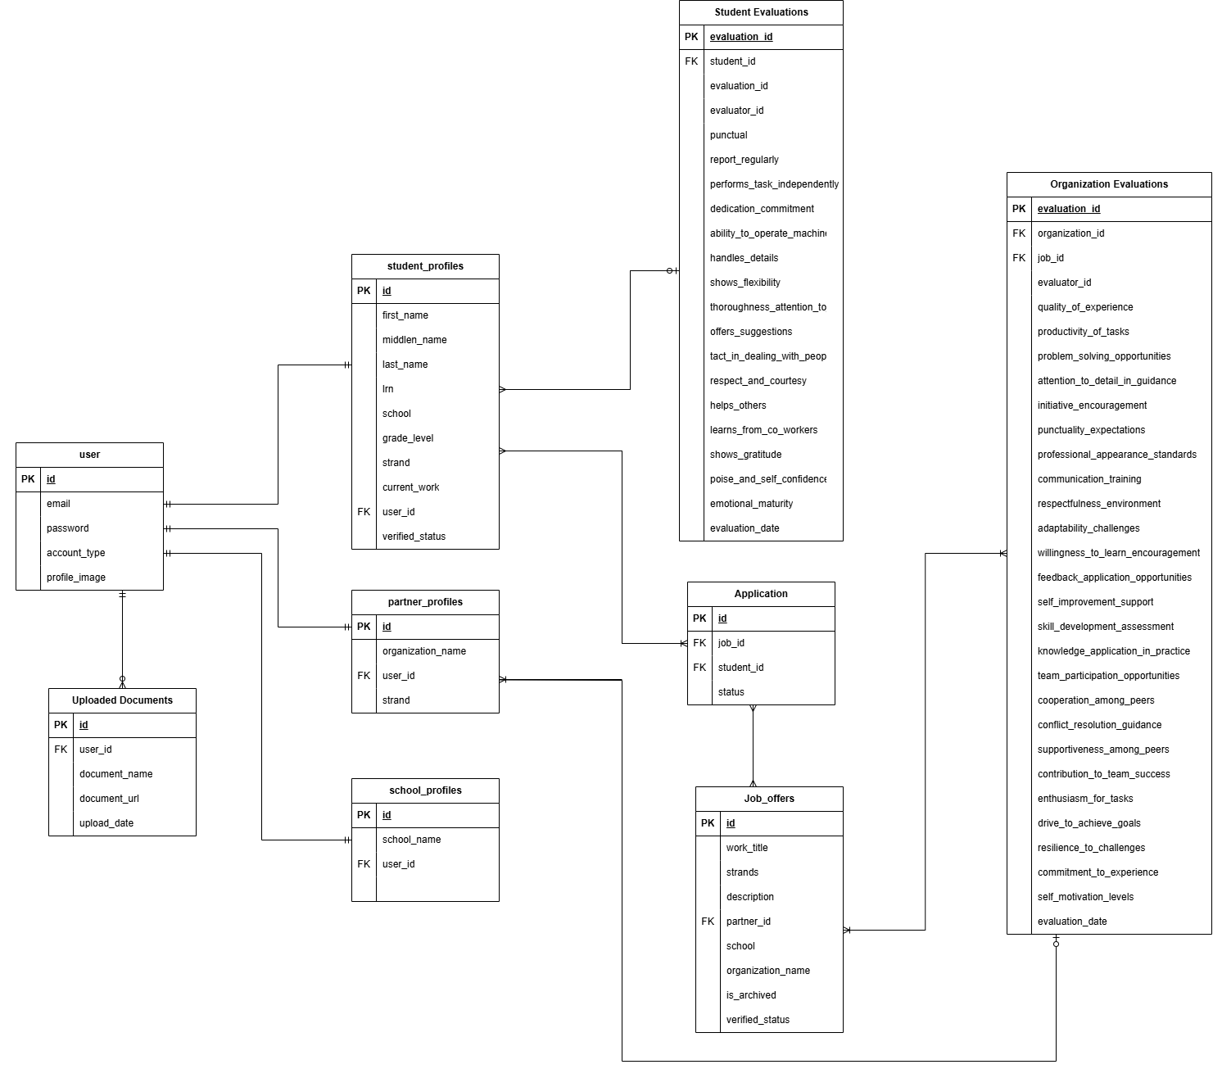

**Figure 6: Entity Relationship Diagram**

**1.1.4 Data Dictionary**

A Data Dictionary is a collection of names, definitions, and attributes about data elements that are being used or captured in a database, information system, or part of a research project. It describes the meanings and purposes of data elements within the context of a project, and provides guidance on interpretation, accepted meanings and representation (UC Merced Library, 2023).

The appendix tables show the data dictionary of the tables used to develop Workify.

Table 4. users – The main table for the users of the website

|  |  |  |  |
| --- | --- | --- | --- |
| Field | Type | Null | Description |
| id | Integer | No | An auto generated identification number |
| email | Varchar(255) | Yes | User’s Email |
| password | Varchar(255) | Yes | User’s Password |
| account_type | ENUM('student', 'school', 'organization') | Yes | The user’s account type if its student, school, or organization |
| profile_image | Varchar(255) | Yes | User’s profile picture |
| cover_image | Varchar(255) | Yes | User’s cover photo |

Table 5. school_profiles – The table for the school account type

|  |  |  |  |
| --- | --- | --- | --- |
| Field | Type | Null | Description |
| id | Integer | No | The system generates id number |
| school_name | Varchar(255) | Yes | School Name |
| user_id | Integer | Yes | School user Id |

Table 6. student_profiles – The table for the student account type

|  |  |  |  |
| --- | --- | --- | --- |
| Field | Type | Null | Description |
| id | Integer | No | An auto generated identification number |
| first_name | Varchar(255) | Yes | Student’s First Name |
| middle_name | Integer | Yes | Student’s Middle Name |
| last_name | Varchar(255) | Yes | Student’s Last Name |
| lrn | Varchar(12) | Yes | Student’s Learner Reference Number |
| school | Varchar(255) | Yes | Student’s school |
| grade_level | ENUM(11, 12) | Yes | Identifies the grade level |
| strand | ENUM('stem', 'humss', 'abm', 'gas', 'tvl') | Yes | Identifies if the student is STEM, HUMSS, GAS, ABM, or TVL |
| current_work | Integer | Yes | Job id reference |
| user_id | Integer | Yes | Main user ID |

Table 7. partner_profiles – The table for the organization account type

|  |  |  |  |
| --- | --- | --- | --- |
| Field | Type | Null | Description |
| id | Integer | No | The system generates id number |
| organization_name | Varchar(255) | Yes | Name of the organization |
| user_id | Integer | Yes | Main user ID |
| strand | Varchar(255) | Yes | The strand the current partner organization specializes into |

Table 8. job_offers – Table for storing job offers

|  |  |  |  |
| --- | --- | --- | --- |
| Field | Type | Null | Description |
| id | Integer | No | The system generates id number |
| work_title | Varchar(255) | Yes | The name of the work offered to the students |
| strands | Varchar(255) | Yes | Main strand target for this work |
| description | Text | No | The work immersion’s job description |
| partner_id | Integer |  | ID of the owner of the job posted |
| organization_name | Varchar(255) |  | Name of the owner of the job posted |
| is_archived | Boolean |  | Indicator of the entry is archived or not |

Table 9. applications – Table storing the applicants for the job offers

|  |  |  |  |
| --- | --- | --- | --- |
| Field | Type | Null | Description |
| id | Integer | No | The system generates id number |
| job_id | Integer | Yes | The ID of the job the student is applying into |
| student_id | Integer | Yes | ID of the applicant |
| status | ENUM('applied', 'cancelled', 'accepted', 'rejected') | Yes | Status of the applicant if it is cancelled, applied, accepted, or rejected |

Table 10. student_evaluation- Table to store the evaluation points for the students

|  |  |  |  |
| --- | --- | --- | --- |
| Field | Type | Null | Description |
| Evaluation_id | Integer | No | The system generates id number |
| Student_id | Integer | Yes |  |
| Evaluator_id | Integer | Yes |  |

Table 11. Organization_Evaluation - Table to store the evaluation points for the organization

|  |  |  |  |
| --- | --- | --- | --- |
| Field | Type | Null | Description |
| evaluation_id | Integer | No | The system generate id |
| organization_id | Integer | Yes | Score for how would rate the overall quality of your work immersion experience |
| job_id | Integer | Yes | Score for how effectively the tasks were assigned to manage during the immersion |
| evaluator_id | Integer | Yes | Score for how well the immersion provided opportunities to solve real challenges |
| quality_of_experience | Integer | Yes | Score for how thorough the guidance was you received in ensuring high-quality work |
| productivity_of_tasks | Integer | Yes | Score for how proactive the immersion encouraged you to take on additional tasks or responsibilities |
| problem_solving_opportunities | Integer | Yes | Score for how well the immersion program emphasized punctuality in arriving and meeting deadlines |
| attention_to_detail_in_guidance | Integer | Yes | Score for how effectively the immersion set standards for professional attire and grooming |
| initiative_encouragement | Integer | Yes | Score for how effective the immersion in was improving your communication skills with peers and supervisors |
| punctuality_expectations | Integer | Yes | Score for how well the immersion fostered a respectful environment among colleagues and supervisors |
| professional_appearance_standards | Integer | Yes | Score for how well the immersion prepared you to adjust to changes in the work environment or tasks |
| communication_training | Integer | Yes | Score for how open the immersion made you feel about acquiring new skills and knowledge |
| respectfulness_environment | Integer | Yes | Score for how effectively the immersion provided opportunities to apply feedback for performance improvement |
| adaptability_challenges | Integer | Yes | Score for how actively the immersion encouraged you to seek opportunities for self-improvement |
| willingness_to_learn_encouragement | Integer | Yes | Score for how well the immersion facilitated your skill development over the course of the experience |
| feedback_application_opportunities | Integer | Yes | Score for how effectively the immersion allowed you to apply theoretical knowledge to practical tasks |
| self_improvement_support | Integer | Yes | Score for how actively the immersion encouraged participation in team activities and discussions |
| skill_development_assessment | Integer | Yes | Score for how well the immersion fostered cooperation among participants to achieve common goals |
| knowledge_application_in_practice | Integer | Yes | Score for how effectively did the immersion address conflict resolution within the team |
| team_participation_opportunities | Integer | Yes | Score for how supportive the environment was created by the immersion towards team members |
| cooperation_among_peers | Integer | Yes | Score for how valuable you believe your contributions were to the team's success during the immersion |
| conflict_resolution_guidance | Integer | Yes | Score for how enthusiastic you about your tasks and responsibilities throughout the immersion were |
| supportiveness_among_peers | Integer | Yes | Score for how driven you felt to achieve your goals and exceed expectations during the immersion |
| contribution_to_team_success | Integer | Yes | Score for how well you handled stress and setbacks experienced during the immersion |
| enthusiasm_for_tasks | Integer | Yes | Score for how committed you to were completing your work and contributing to the organization during the immersion |
| drive_to_achieve_goals | Integer | Yes | Score for how motivated you felt to take initiative and pursue your own improvement throughout the immersion |
| resilience_to_challenges | Integer | Yes | Score for ability to manage and control emotions, especially in difficult or stressful situations. |
| commitment_to_experience | Integer | Yes | Score for a willingness to try new things, explore different perspectives, and step outside one’s comfort zone. |
| self_motivation_levels | Integer | Yes | Score for highly self-motivated individuals set clear, meaningful goals for themselves and are determined to achieve them, regardless of external circumstances. They have a strong sense of purpose. |
| evaluation_date | Integer | Yes | Score for the evaluation date is often used to measure the effectiveness or success of specific initiatives, goals, or objectives within a defined timeframe. |

**1.1.5 Data Flow Diagram**

As stated by Davis (2019), data flow diagrams (DFDs) are a useful tool in describing how data flows in a particular system and the processes, data stores and external entities involved in this movement. These DFDs are very important when carrying out system implementation since they help the stakeholders to grasp the various functions and interactions of data in the system.

Figure 8 here shows the interconnectivity of components that display how this diagram allows a senior high school work immersion program focusing on student profiles, performance evaluation, feedback, and survey processes in an overall data analytics system for streamlining management.

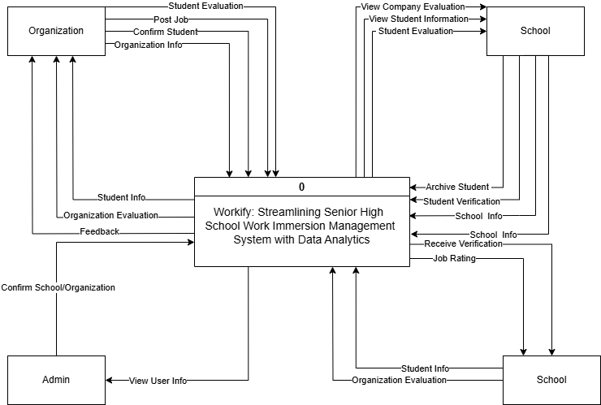

**Figure 8: Context Diagram**

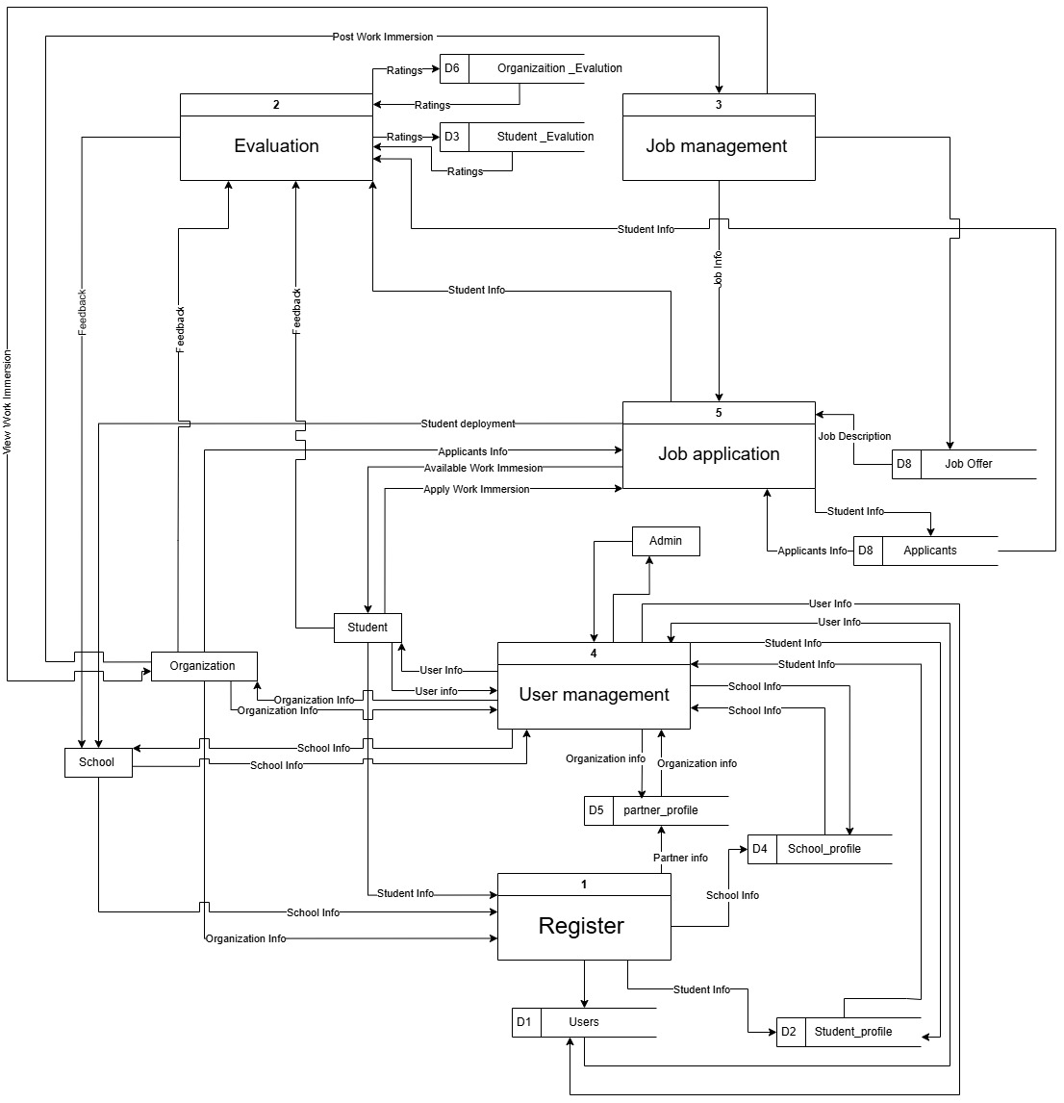

**Figure 9: Low-Level DFD**

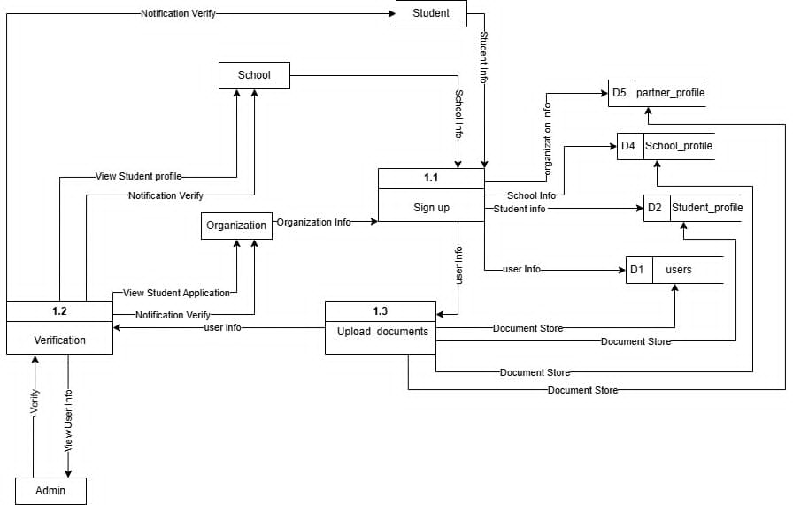

**Figure 10: Level 0 DFD**

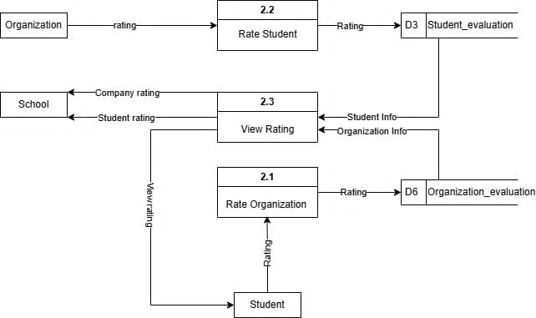

**Figure 11: Context Level DFD**

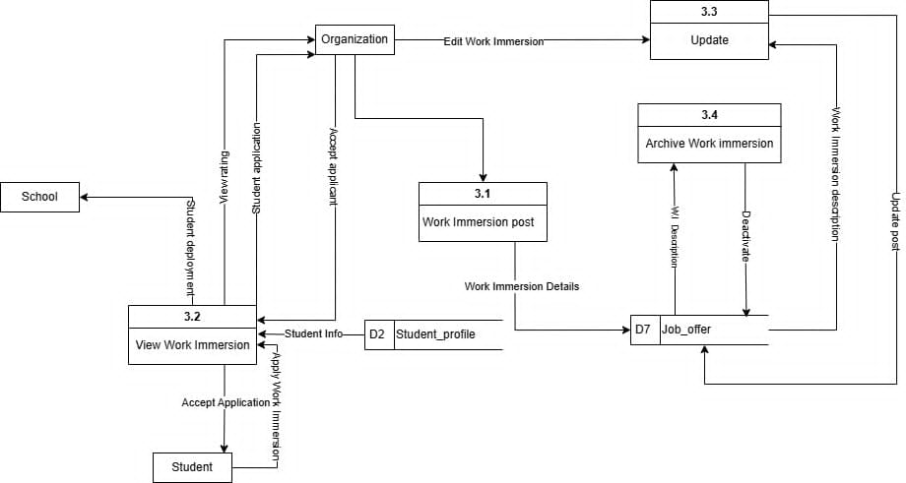

**Figure 12: Context Level DFD**

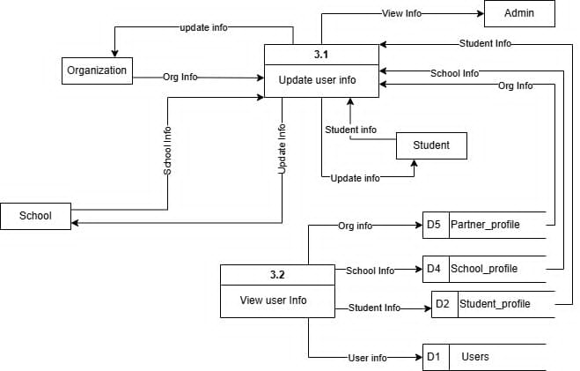

**Figure 13: Context Level DFD**

**1.1.6 Use-Case Diagram**

Use case diagrams are useful to identify requirements from the user’s point of view effectively capturing a picture of the flow of system actions. They depict the sequences of user (actor) and system use cases, that are useful in requirements gathering and system conceptualization. Literature by Seidl et al (2015) describes that use case diagrams convey what a system should perform without implementation specifics, focusing instead on user interactions.

The main components of a use case diagram are:

**Use Cases.** A use case is a precise narrative that outlines the users’ requirements to use a system, object, or components, based on certain objectives or goals (Koelsch, 2023).

**Actors.** They have primary actors who use the system and secondary actors who support or offer their services (Song, 2015).

**Associations.** The use case diagrams are important documents, which show the connections between various elements in the process of software creation. Associations enable one to find out possible relationships of requirements and this is important when it comes to managing projects and controlling software failure (Gelu et al., 2018).

**System Boundaries.** A system boundary is a rectangle that is often drawn in a use-case diagram to represent a line that divides internal use cases with external actors. A systemboundary is also drawn as a sketch in the diagram; it does not contribute any concept to the model (IBM, 2023).

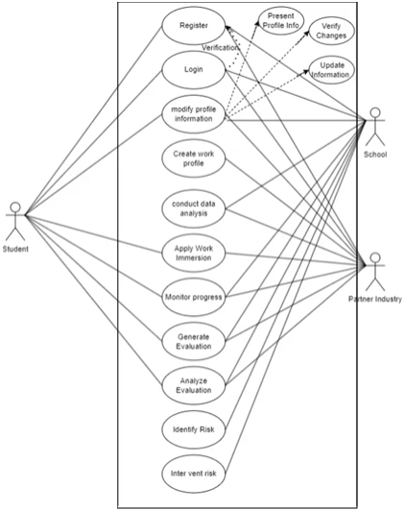

**Figure 14: Use Case Diagram**

**1.1.7 Wireframes**

**Figure 15: Home Page**

* List and Search Work Immersion

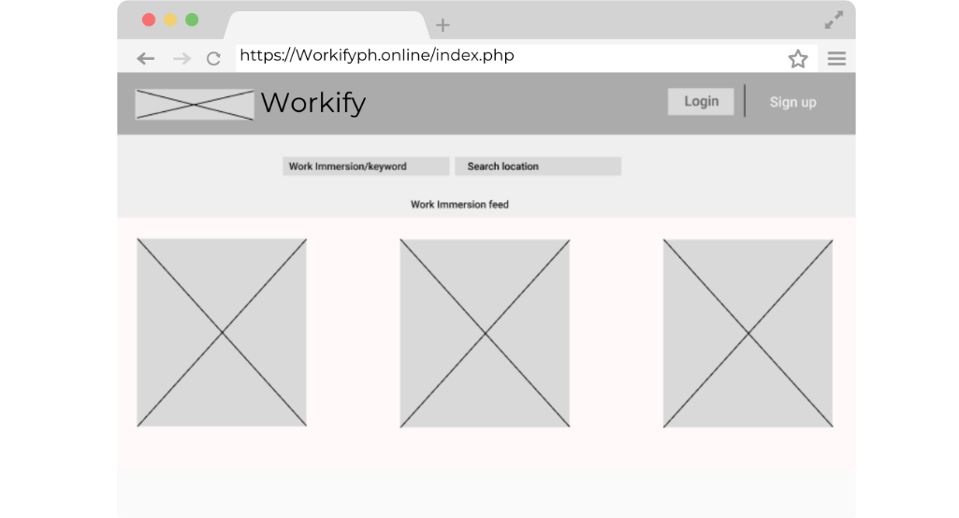

**Figure 16: Login Form**

* Authenticate Users, Granting Them Secure Access to Their Personalized Workspace

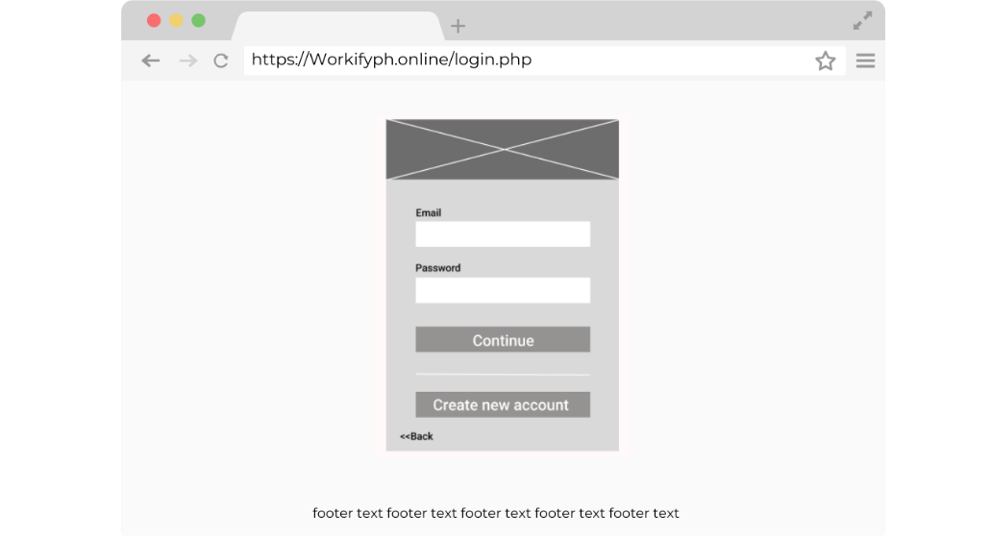

**Figure 17: Create Account Form**

* Allow Users to RegisterThis Application to Establish Secure Access to Personalize features.

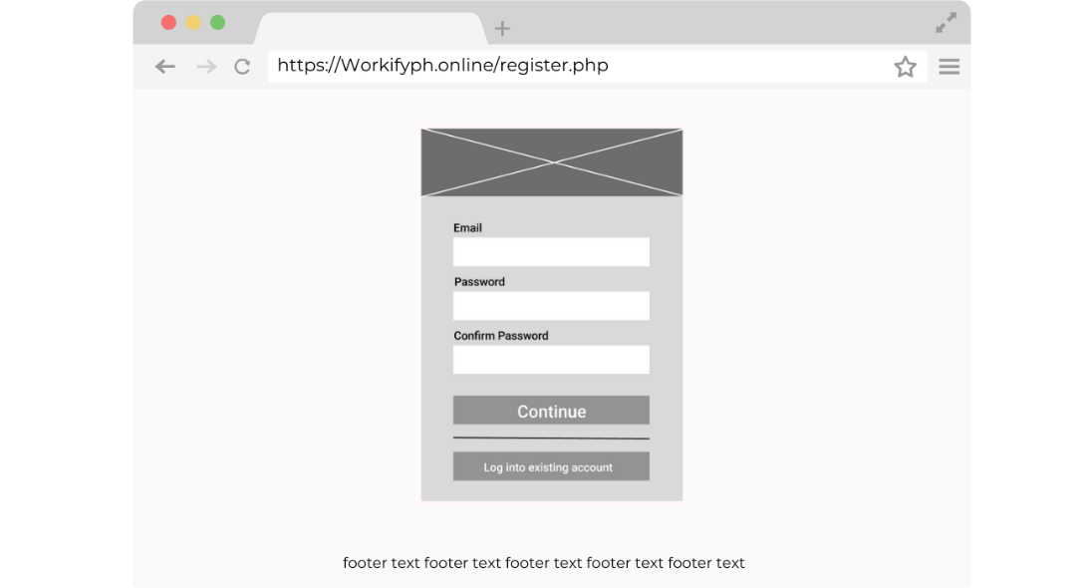

**Figure 18: Student Landing Form**

* User Information for Account Create and Providing Access to the Applications Features.

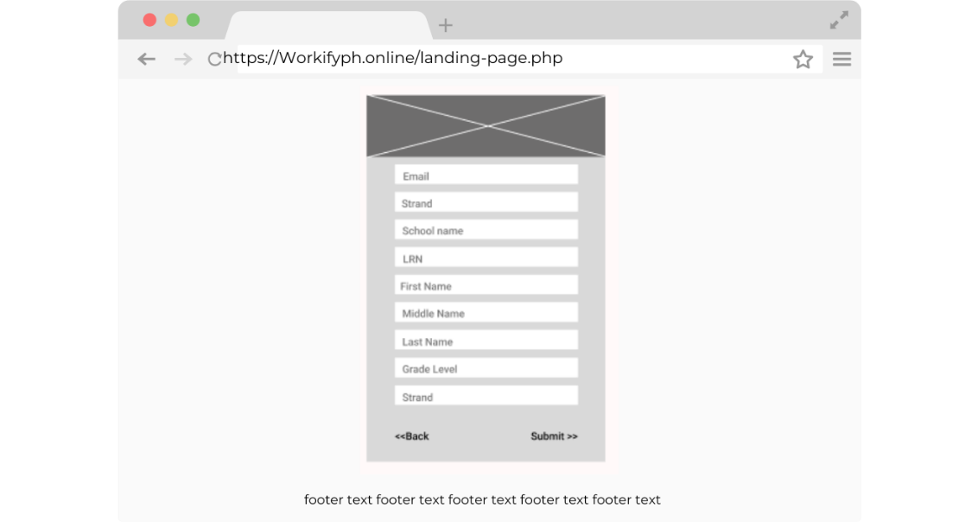

**Figure 19: Student Dashboard**

* The Dashboard Displays a Student's Profile, Searchable Company Area for Work Immersion, Top Company Reviews, And A Narrative Student Assessment Report.

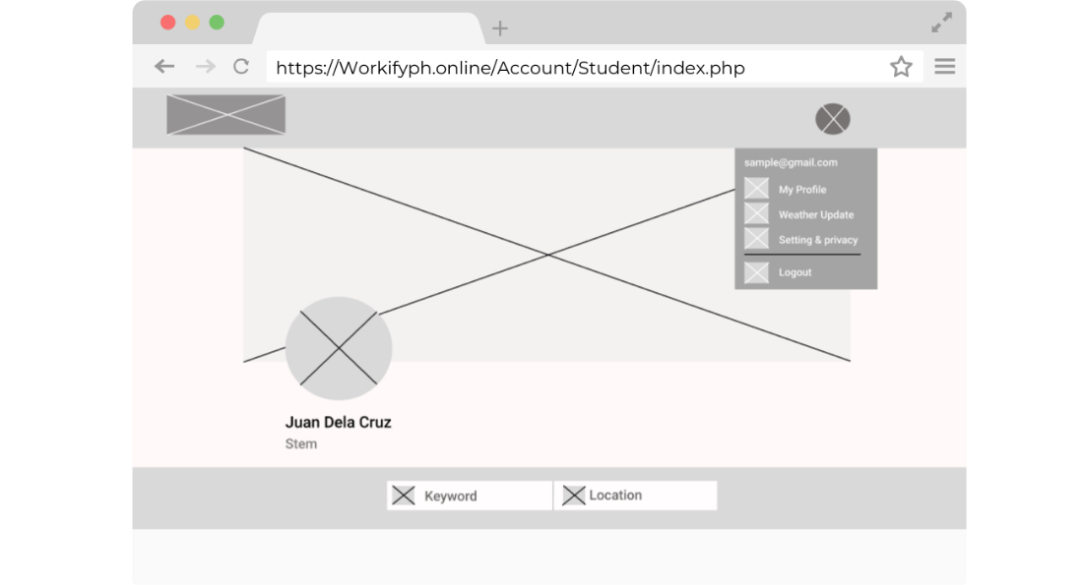

**Figure 19: Work Immersion Advertise**

* Allowing Users/Students to View the Details of Work Immersion and Apply for Their Chosen Options.

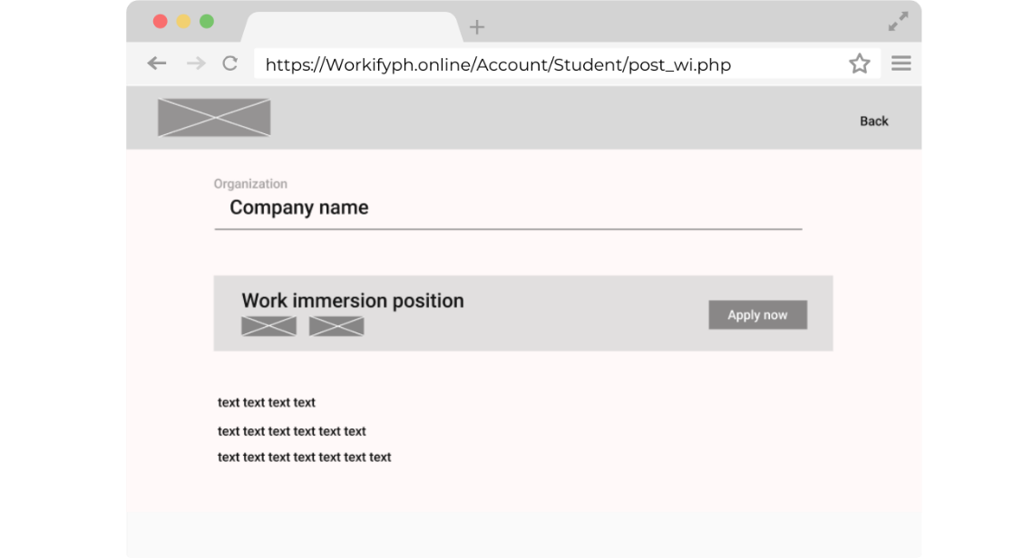

**Figure 20: Student Evaluation Form**

* Assess and comment on the performance, skills, as well as experiences of a student during work immersion from the company.

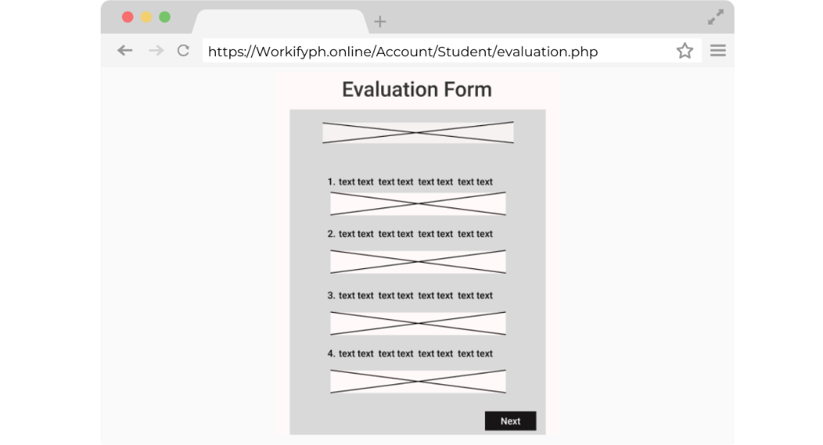

**Figure 21: Company Landing Form**

* Users Input Information and Choose Account Type If a Partner Organization, Student, Or School.

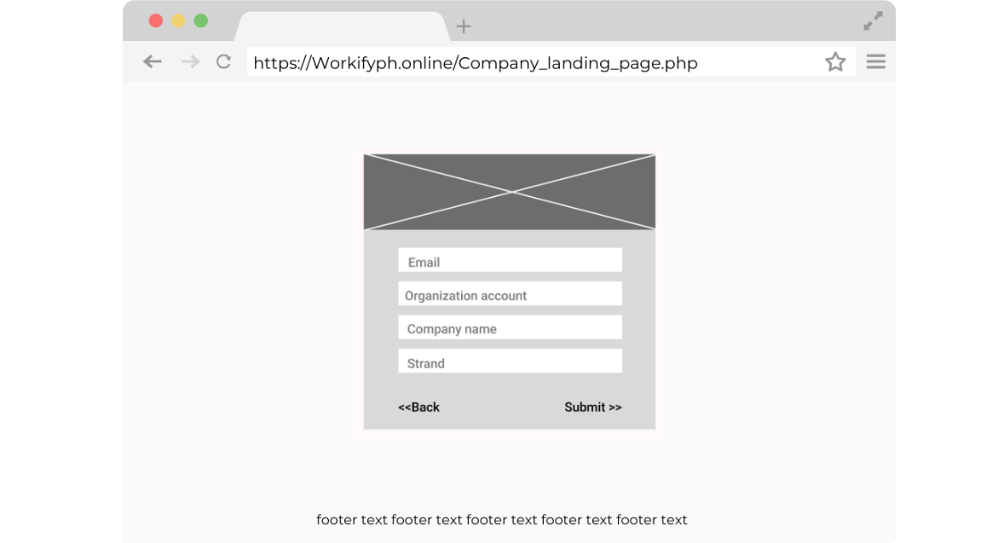

**Figure 22: Company Dashboard**

* User-Friendly Interface in Managing Job Posting

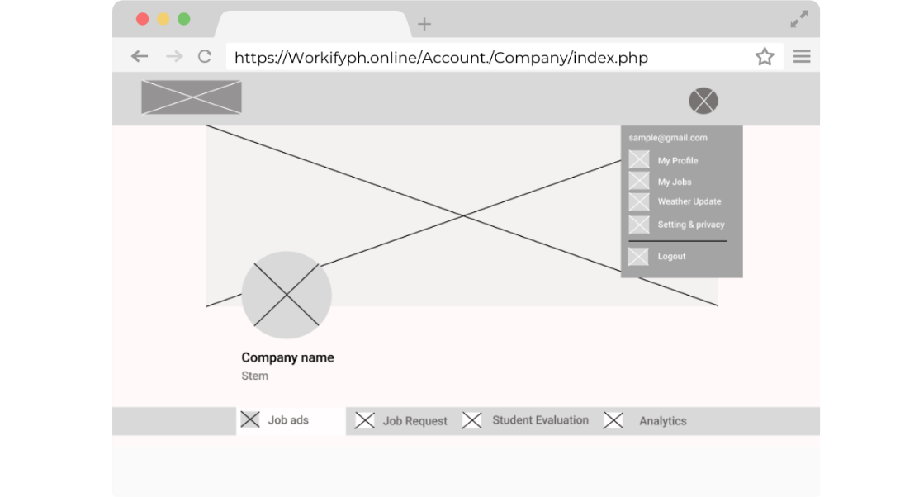

**Figure 23: Job Ads Form**

* Enable Users to Create a Job Posting Based on The Input Form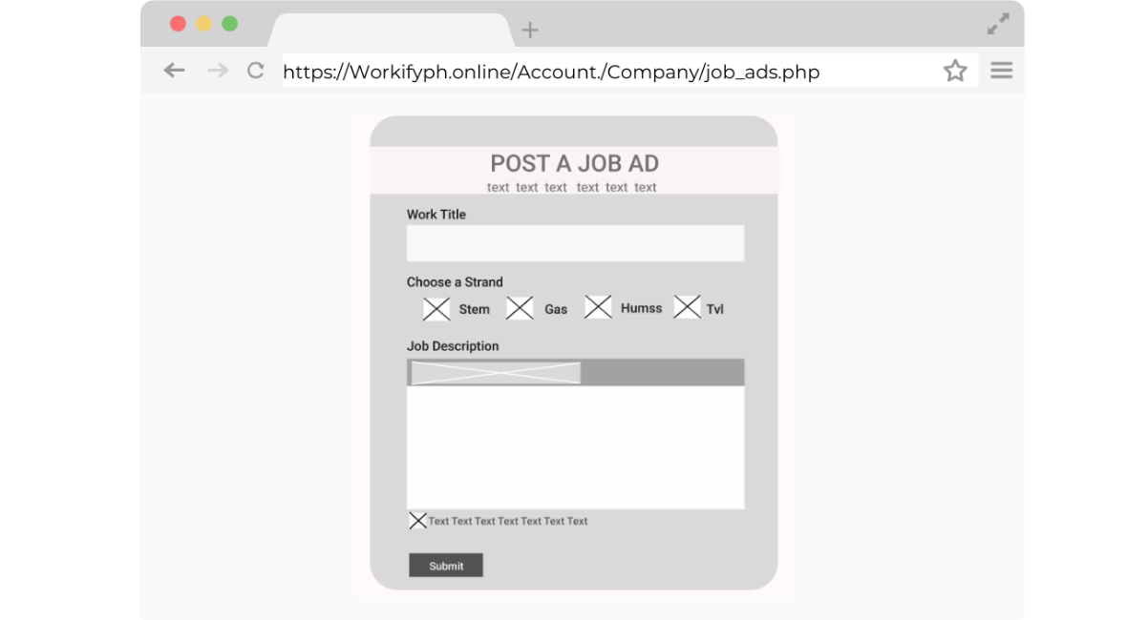

**Figure 24: Student Request Form**

* Table for Students' Job Requests.

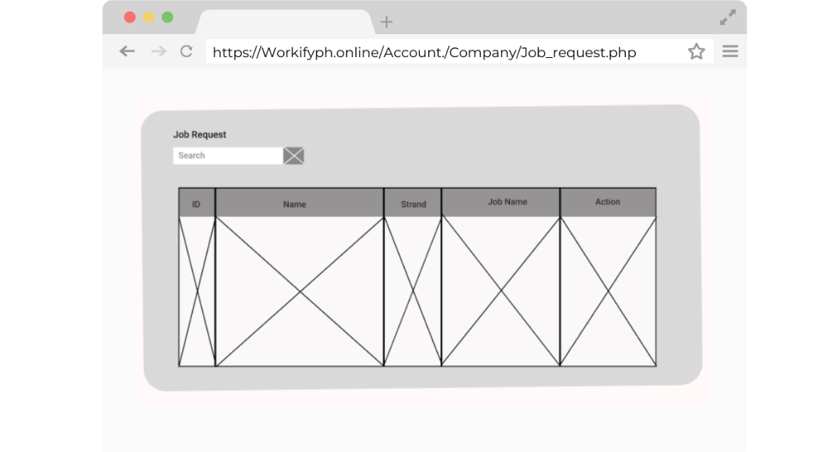

**Figure 25: Student List Form**

* It Makes It Possible for the Administrators to Evaluate and Monitor Students' Performances by Giving a List of Individuals with Choices of Evaluating the Outputs of Every Student.

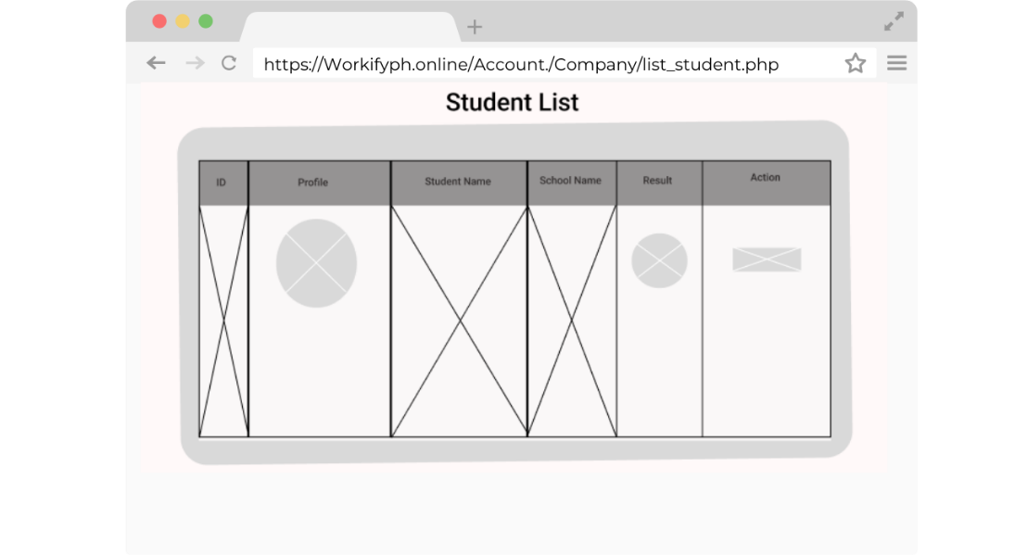

**Figure 26: Company Evaluation Form**

* Assesses the Student Performance During Work Immersion by Evaluating Criteria Such as Work Habits, Work Skills and Social Skills

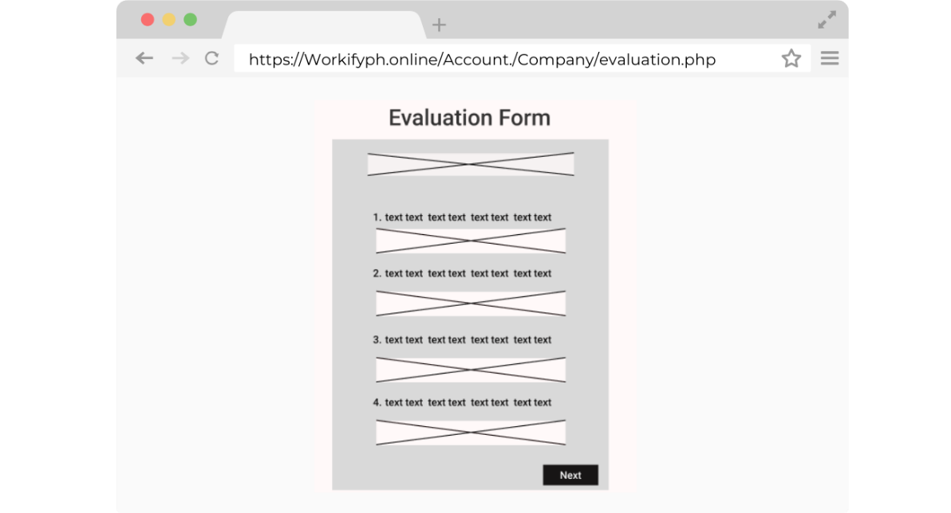

**Figure 27: Student View Profile Form**

* This Displays a List of Students in Different Academic Tracks

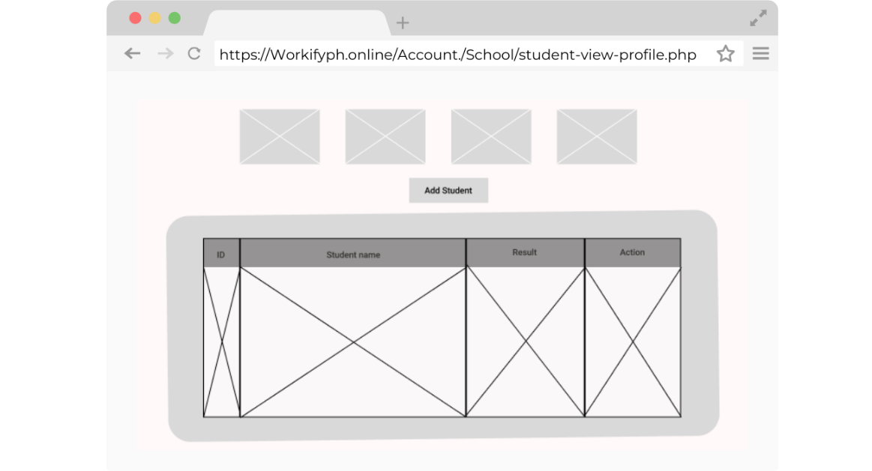

**Figure 28: Student Report Form**

* This is a List of Students Attached to Other Companies. In This Case, One Can Have a Detailed Report or Archived Records of Every Student

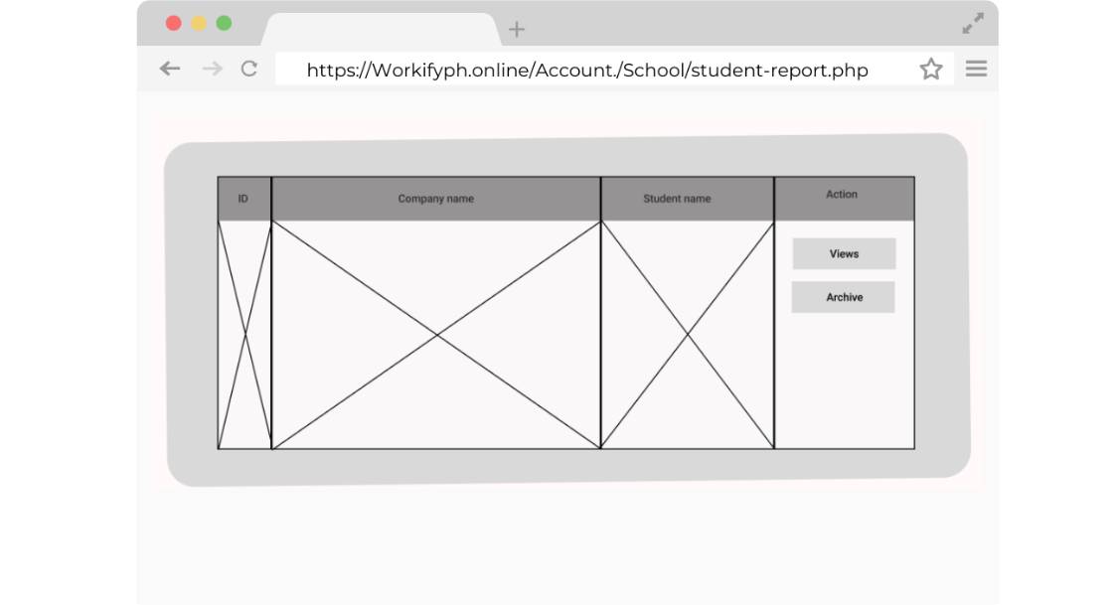

**1.2 Sprint**

The sprint development phase, especially agile approaches to software development, is typified by series of cycles and teamwork geared towards achieving maximum production and creativity. Within this, efforts are organized in fixed short periods of work called sprints in which a team tends to specific objectives making it easier to create and refine ideas. As stated by Raubenolt (2016), meetings are organized to focus on certain tasks, mostly lasting a week for instance when teams work on sprints to create solutions, which improves the decision-making process and responsibility

**1.2.1 System Development**

The proponents utilized HTML, CSS, JavaScript, and PHP for front-end design, establishing the structure, design, and management of dynamic content generation. JavaScript, MySQL and PHP facilitated capabilities such as data analytics, job search, and evaluation of students and employment in the development of the back-end. Visual Studio Code serves as the principal integrated development environment (IDE) utilized by advocates for coding and testing, whilst Hostinger was employed for system deployment and live testing.

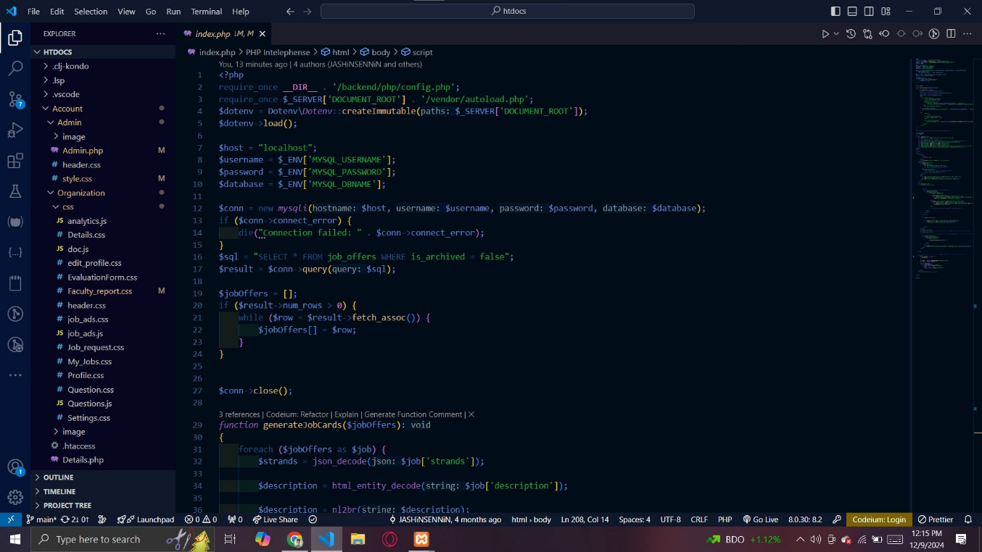

**Figure 29: Visual Studio Code IDE**

**1.2.2 Database Development**

The proponents used MySQL during the development of the system to develop the database. XAMPP is a free, open source, and versatile web server solution simplifying the installation and configuration of MySQL, along with other components like Apache and PHP. More importantly, it is very beneficial for the application developers.

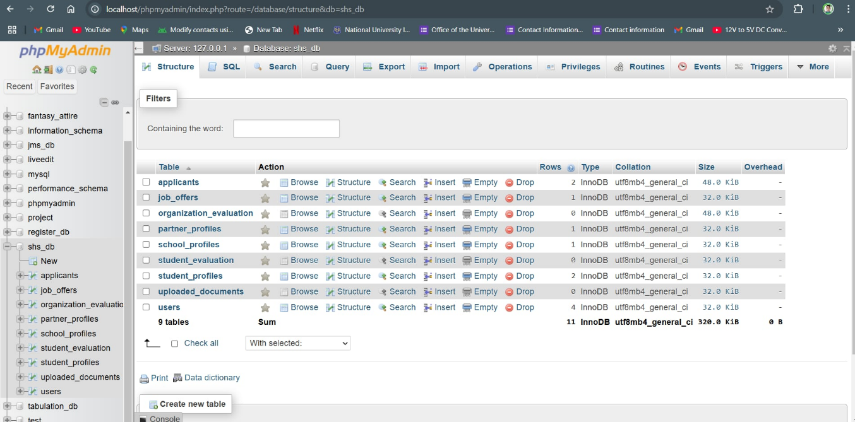

**Figure 30: MySQL XAMPP IDE**

**1.3 Sprint Review**

During the sprint review, the proponents presented their most recent revision of the system, showing the functionalities and enhancements made during the sprint. The proponents consulted Dr. Ramon's teacher to get their feedback, thoughts, and opinions on the effectiveness of the system. The system presentation focused on showing interesting new features to meet the client's demand. The proponents obtained positive feedback and suggestions from the client for the development required by the system, to ensure better quality results.

**1.3.1 Presentation of the System to Customer for Feedback**

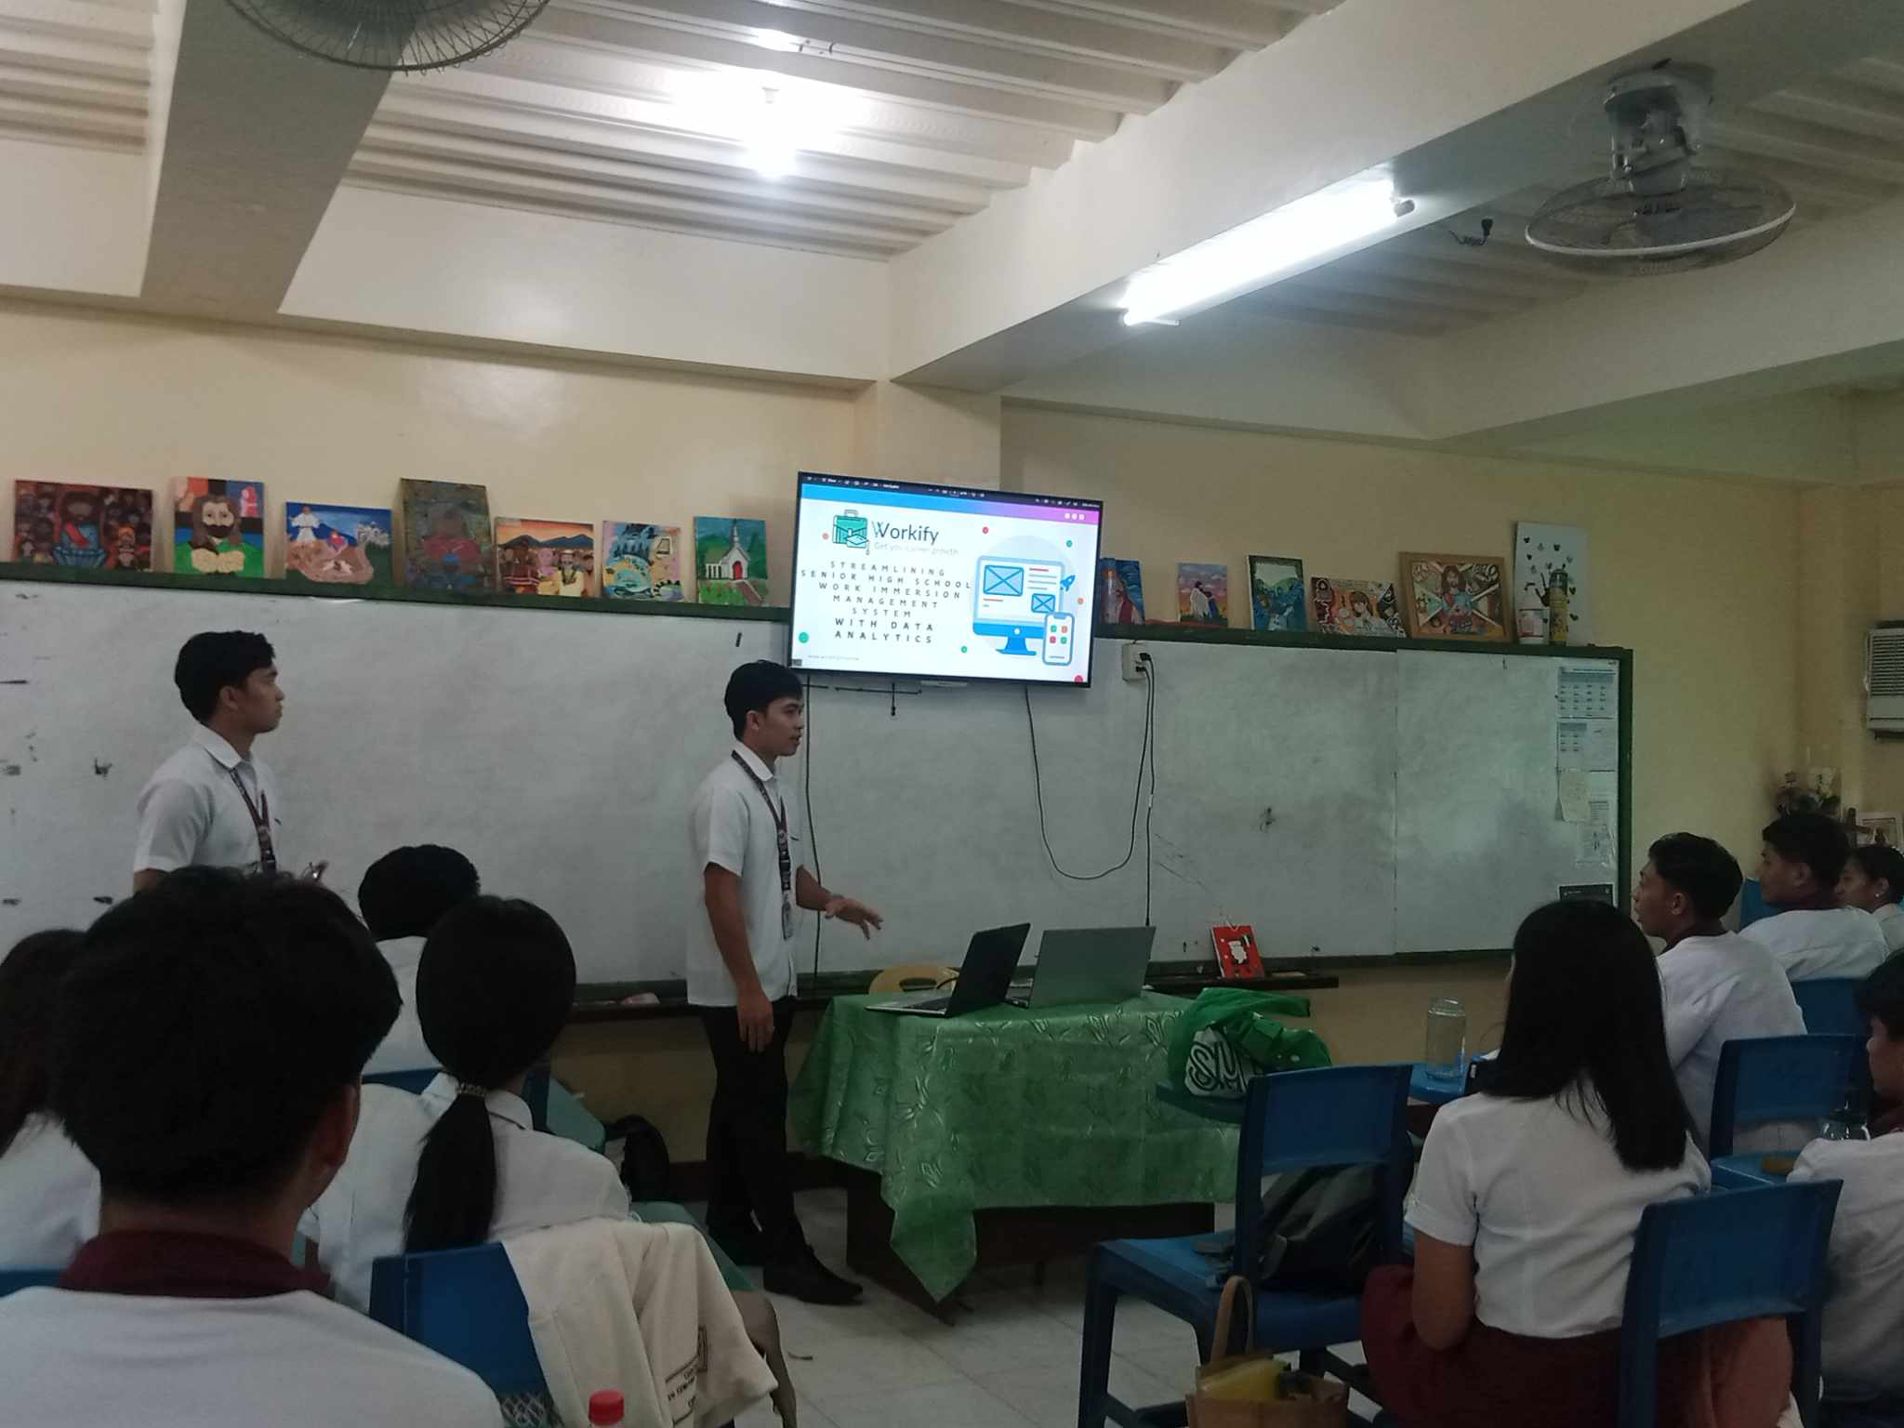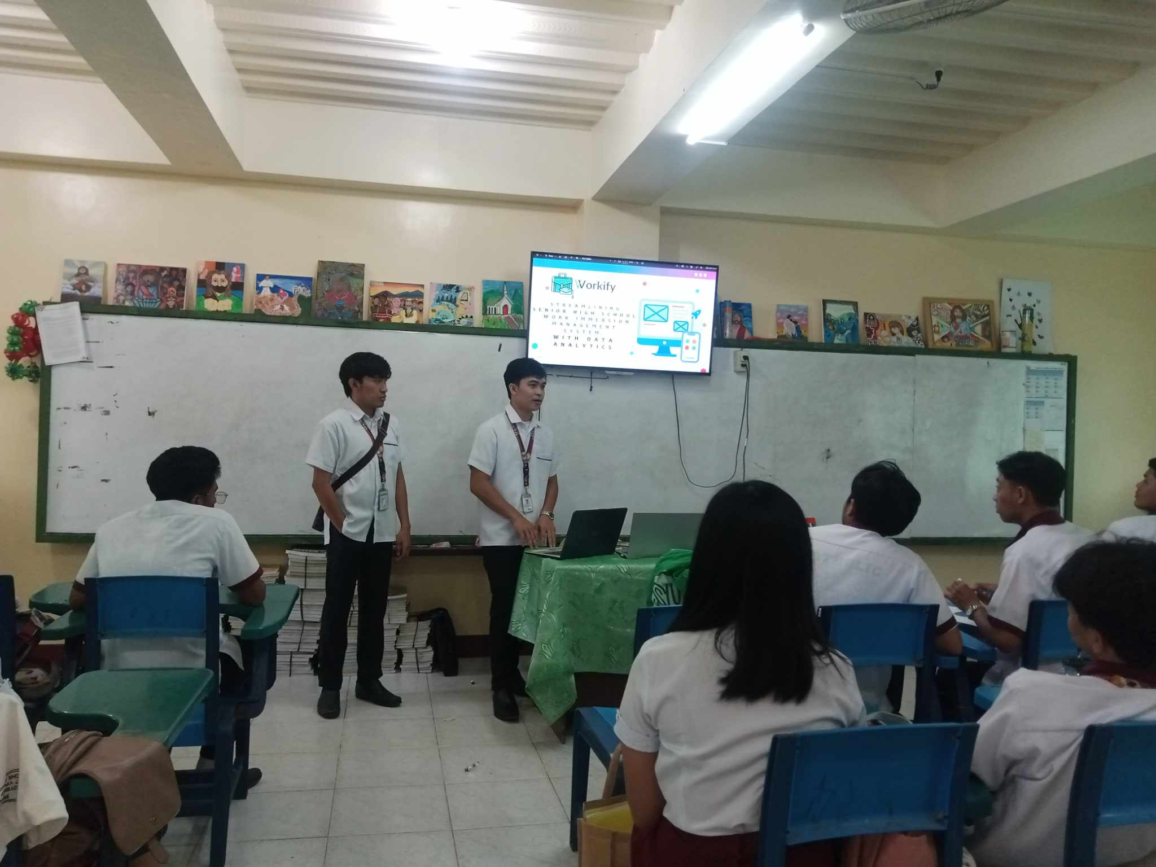

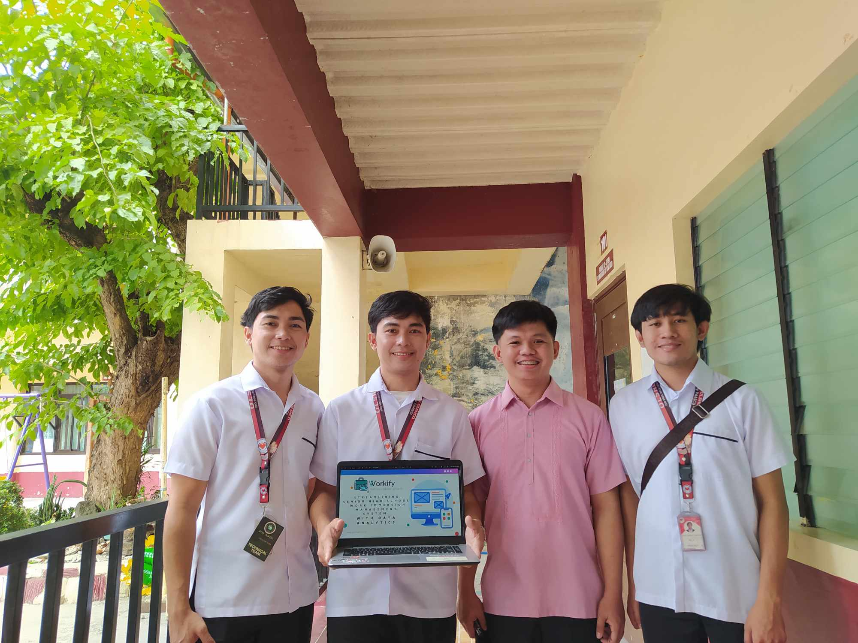

**Figure 31: Documentation**

**1.4 Sprint Retrospective**

**1.4.1 What Went Well**

Throughout the development of Workify: Streamlining the Senior High School Work Immersion Management System with Data Analytics, the proponents implemented major changes to the website and achieved some notable successes. Although the proponents went through many difficult processes, they achieved some level of success.

* Successful Feature
* Integration
* Strong Collaboration
* Effective Strategies
* Daily Meetings
* Future Planning
* Accomplishment Focus

**1.4.2 What Didn’t Go Well**

Although there are successes in the development of the system, it also involves the existence of problematic situations that the proponents faced in the development of Workify: Streamlining the Senior High School Work Immersion Management System with Data Analytics.

* Misunderstanding in Communications
* Implementation Challenges
* Technical Difficulties
* Delayed Tasks
* Impact on Progress

**1.4.3 Actionable Item for Improvements**

To improve system performance in the next sprint, proponents implement a more organized front-end and back-end. Additionally, the proponents had bug fixes and penetration testing to ensure the smooth presentation of the system and improve the overall features of the website in line with the vision or the planned outcome of the proponents in the system.

**1.5 Increment Delivery / Implementation of the System**

**1.5.1 Implementation of the Database and System**

Web hosting is a type of service that allows individuals and organizations to publish their web content on the internet. Each one has its own particular purpose, for example shared hosting is perfect for small websites while a dedicated server can power large organizations who need great speed and security.

The proponents used Hostinger as their web hosting of choice for Workify: Streamlining Senior High School Work Immersion Management System with Data Analytics because it offers affordable, fast servers and high-performance consistent customer satisfaction along with excellent uptime rates; making them not only the best for an experienced developers but also perfect for a new starter.

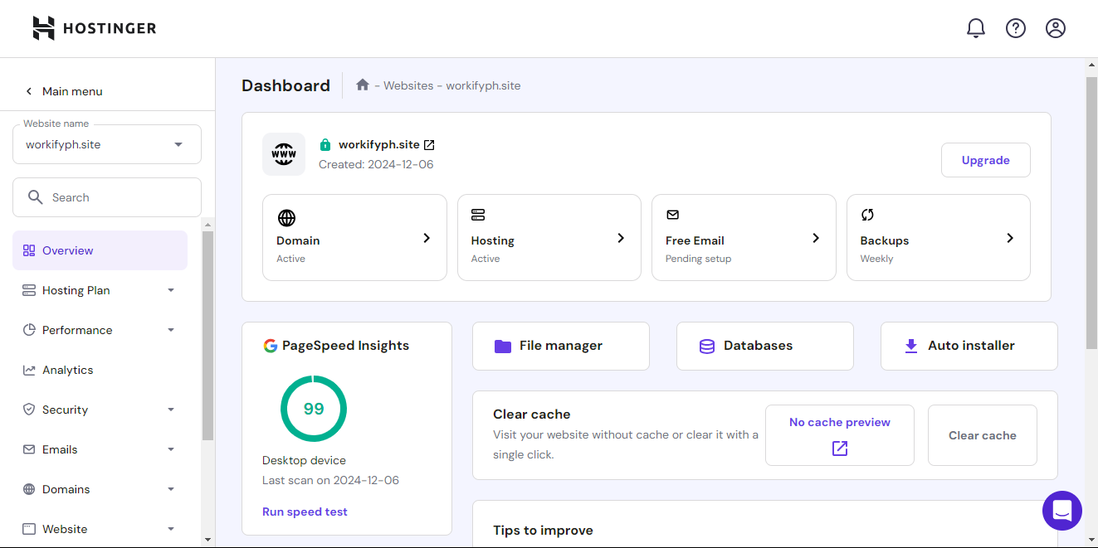

**Figure 32: Hostinger H Panel Overview**

**1.5.2 Final System Manual**

The goal of this phase is to provide a complete and high-fidelity visual representation of the final design, incorporating details such as typography, colors and interactive functionality. These graphical user interfaces are to establish and create a technical blueprint on how web applications work. High-fidelity wireframes help to gather valuable feedback regarding the look and feel of the product and help ensure that design choices are in alignment with user needs as well as business goals by providing an almost final appearance of the view.

The Following Figure Shows the Final System Manual of the Workify Website Application.

**Name:**  Home page

**Description:**  List and Search Work Immersion

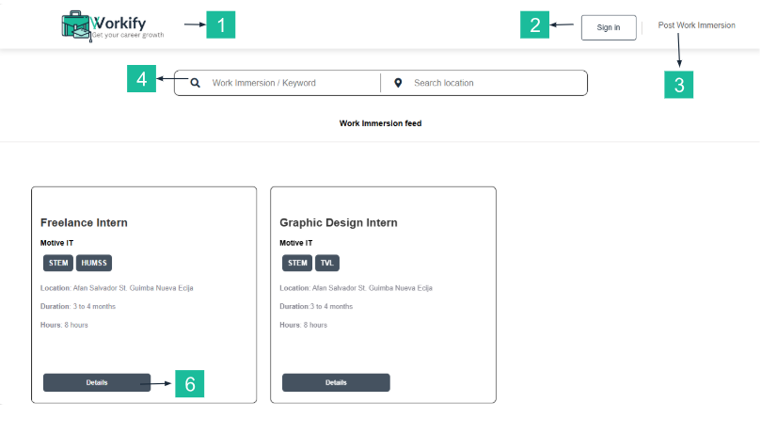**Figure 10: Home Page**

|  |  |
| --- | --- |
| **Name of Control** | **Description** |
| 1. Logo / Workify Button | The logo of the website is usually located at the top-left corner is the brand's identity and is often clickable and can redirect users to the homepage for easy navigation. |
| 2. Sign-In Button | Allowing the user to log in to the website. |
| 3. Post Work Immersion Button | It is allowed to post a work immersion for those who have a business or organization |
| 4. Keywords / Location Search Bar | Allowing users to quickly find relevant work immersion based on specific terms or geographic areas, thereby filtering search results efficiently. |
| 5.Details Button | Allowing users to see details of work immersion posts. |

**Name:**  Login Form

**Description:** Authenticate Users, Granting Them Secure Access to Their Personalized Workspace.

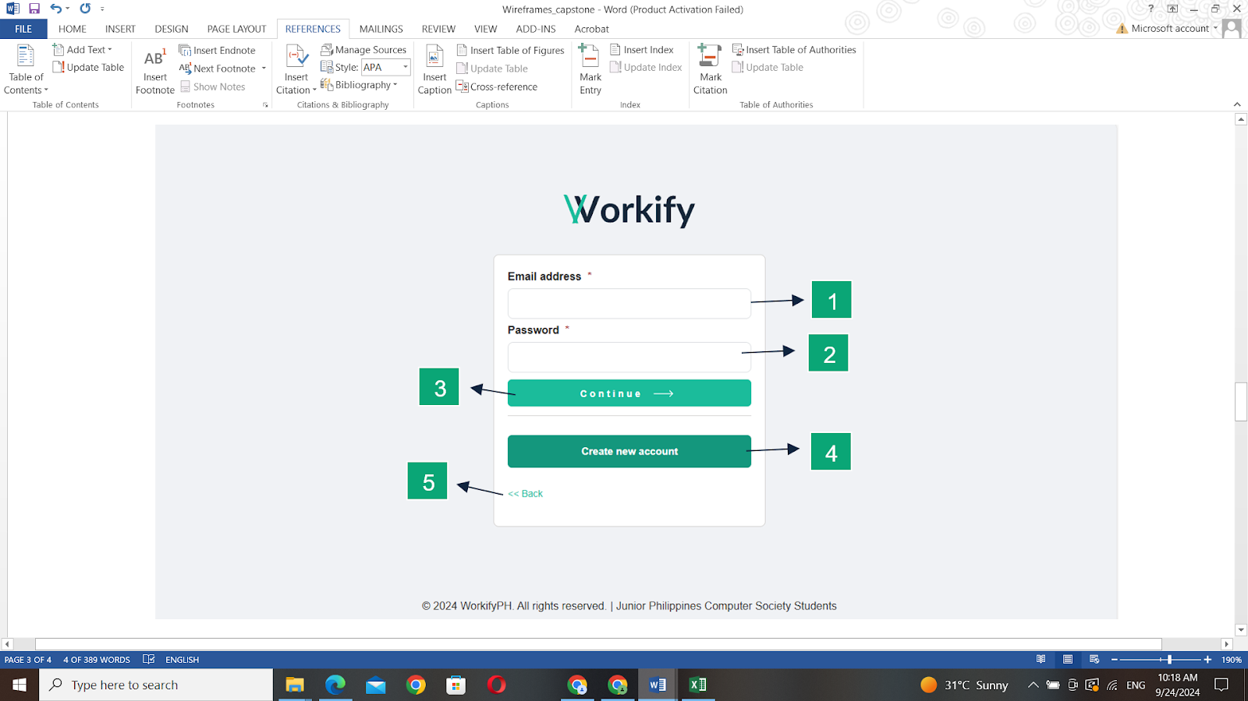

**Figure 11: Login Form**

|  |  |
| --- | --- |
| **Name of Control** | **Description** |
| 1. **Email Address textbox** | User will enter his email address in this textbox to if he is already register of this application |
| 1. **Password Textbox** | Validates that the user has the right to access the application. |
| 1. **Continue Button** | Send and check if the email and password is in the database. |
| 1. **Create Account Button** | Allows users to manage their task while ensuring personalized features and security access to their work-related data. |
| 1. **Back button** | Allow users to easily navigate the previous screen. |

**Name:** Create Account Form

**Description:** Allow Users to RegisterThis Application to Establish Secure Access to Personalize features.

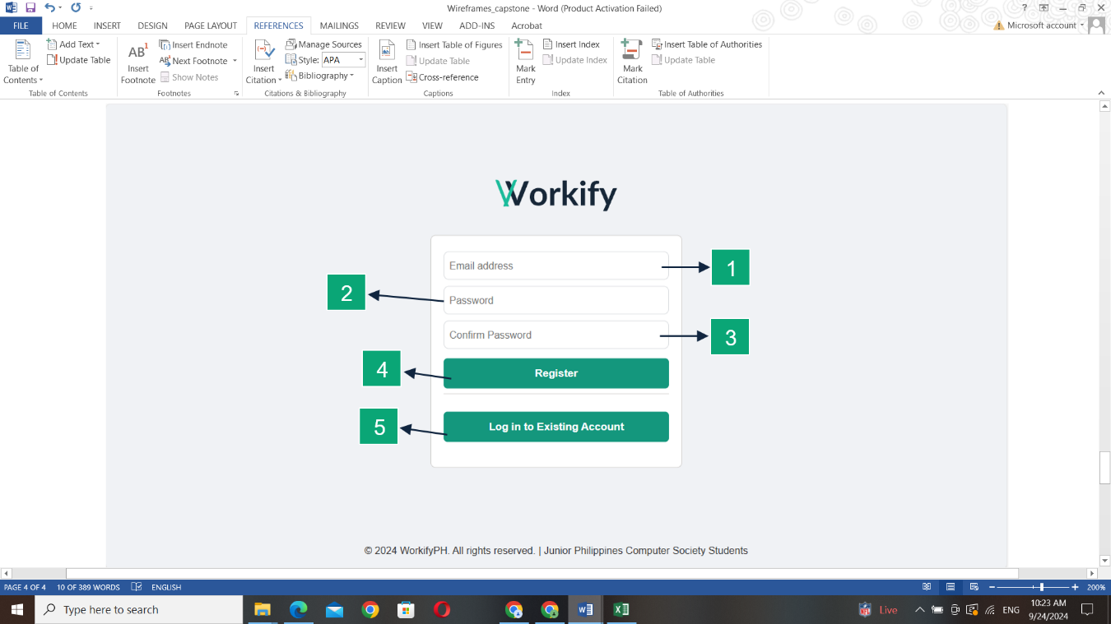

**Figure 12: Create Account Form**

|  |  |
| --- | --- |
| **Name of Control** | **Description** |
| 1. **Email Address textbox** | New user key-in his desired email in textbox. |
| 1. **Password textbox** | Provide a secure environment for users to protect their personal accounts and sensitive information. |
| 1. **Confirm password button** | Ensure that users accurately enter their desired password. |
| 1. **Register Button** | Submit the user's information for creating an account to grant access to the application. |
| 1. **Login to existing account button** | Users can easily navigate login if the user has an account or didn’t want to register. |

**Name:**  Student Landing Form

**Description:** User Information for Account Create and Providing Access to the Applications Features.

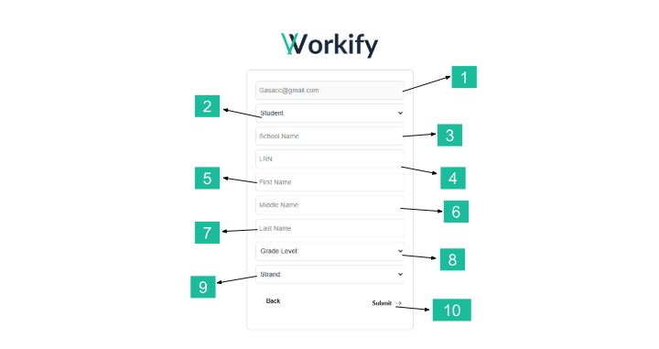**Figure 13: Student Landing Form**

|  |  |
| --- | --- |
| **Name of Control** | **Description** |
| 1. **Selection List** | This is the selection to determine the registrant on the form. |
| 1. **Account Type** | Allowing the user to choose the account type. |
| 1. **School Name Textbox** | Users are required to provide a school name. |
| 1. **Learn Reference Number (LRN) Input Box** | Requires users to input LRN to verify their identity. |
| 1. **First Name Textbox** | Requires the user to input their first name. |
| 1. **Middle Name Textbox** | Requires the user to input their middle name. |
| 1. **Last Name Textbox** | Requires the user to input their last name. |
| 1. **Grade Level Selection List** | The user is able to select the proper grade level from the available choices. |
| 1. **Strand Selection List** | Users are able to choose the strand to which they belong. |
| 1. **Submit Button** | Facilitates the finalizing of a user's input |

**Name:** Student Dashboard

**Description:** The Dashboard Displays a Student's Profile, Searchable Company Area for Work Immersion, Top Company Reviews, And A Narrative Student Assessment Report.

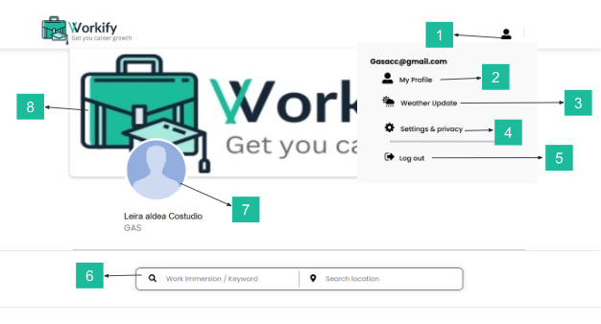**Figure 14: Student Dashboard**

|  |  |
| --- | --- |
| **Name of Control** | **Description** |
| **1.Profile Dropdown** | Service that makes it possible for users to interactively manage their profile and settings. |
| **2.My Profile Button** | Allows users to view personal information. |
| **3. Weather Update Button** | Provide real time weather information to forecast and alert for their specific locations. |
| **4.Setting & Privacy Button** | Manage the account of the user and allow them to change a password. |
| **5.Logout Button** | End the user's session to ensure their account is protected from unauthorized access. |
| **6.Search Location/Location Search Bar** | Allowing users to quickly find relevant work immersion based on specific terms or geographic areas, thereby filtering search results efficiently. |
| **7.Profile Picture** | It contains a picture that identifies who the user is. |
| **8.Cover Photo** | Users can upload a picture that represents them or their school. |

**Name:** Work Immersion Advertise

**Description:** Allowing Users/Students to View the Details of Work Immersion and Apply for Their Chosen Options.

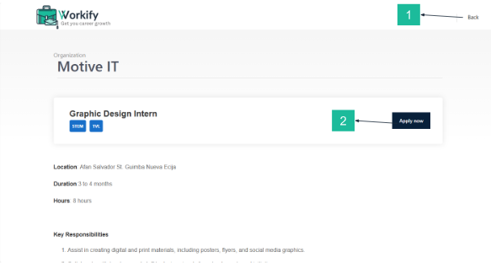

**Figure 15: Work Immersion Advertise**

|  |  |
| --- | --- |
| **Name of Control** | **Description** |
| **1. Back button** | Allow users to easily navigate the previous screen. |
| **2. Apply button** | Allowing users to submit their requests and confirm their application for work immersion. |

**Name:** Student Evaluation Form

**Description:** Assess and comment on the performance, skills, as well as experiences of a student during work immersion from the company.

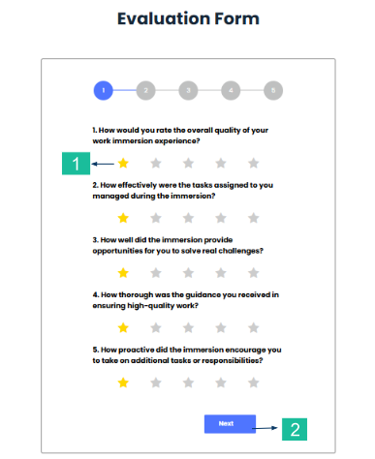

**Figure 16: Student Evaluation Form**

|  |  |
| --- | --- |
| **Name of Control** | **Description** |
| **1. Star Rating** | Provide remarks on the performance and conduct of students in their work immersion. |
| **2. Next Button** | Enables a user to move onto another page or perform an action or advance in a process. |

**Name:** Company Lading Form

**Description:** Users Input Information and Choose Account Type If a Partner Organization, Student, Or School.

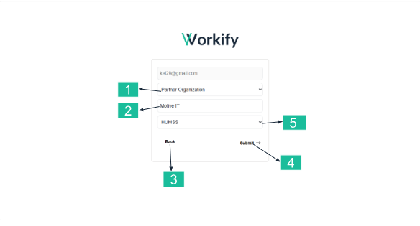

**Figure 17: Company landing Form**

|  |  |
| --- | --- |
| **Name of Control** | **Description** |
| **1.Organization selection** | Identifying and choosing partner organizations that align with the company's goals and objectives. |
| **2.Name Company textbox** | Allows user to enter the name of company. |
| **3.Back button** | Allows user to return to a previous page. |
| **4.Submit button** | To confirm and send the data or selections that users entered. |
| **5.Strand selection** | Users are able to choose the strand to which they belong. |

**Name:** Company Dashboard

**Description:**  User-Friendly Interface in Managing Job Posting

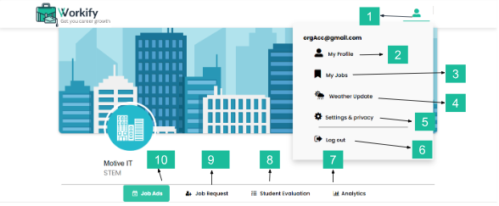

**Figure 18: Company Dashboard**

|  |  |
| --- | --- |
| **Name of Control** | **Description** |
| **1.Profile button** | Provides users with access to their personal information and account settings. |
| **2.My profile button** | Users can view their personal information. |
| **3.My Jobs button** | Allows users to edit their job postings and archive completed or inactive job posts. |
| **4.Setting & privacy button** | Allows users to access and modify their personal information and manage account settings. |
| **6.Logout button** | Allows users exit of their account and close a session to secure personal information. |
| **8.Analytics button** | By clicking on the analytics button, users can view statistical information, trends, and visual representations that help them understand and evaluate the data in a meaningful way. |
| **9.Student Evaluation button** | Allows users to access and perform assessments or evaluations related to students. |
| **10.Job Request button** | Enables users to submit requests for specific job opportunities or positions within the system. |
| **11.Job Ads button** | Users can explore job opportunities posted by employers, review job descriptions, requirements, and application details. |

**Name:** Job Ads Form

**Description:**  Enable Users to Create a Job Posting Based on The Input Form.

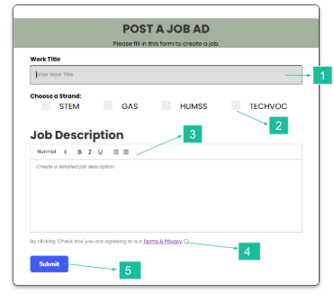

**Figure 19: Job Ads Form**

|  |  |
| --- | --- |
| **Name of Control** | **Description** |
| **1.Enter work title textbox** | Allows users to enter the title of a job position they are posting. |
| **2.Strand checkbox** | This selection helps categorize job applicants based on their educational background and specialization |
| **3.Input textbox** | Used to describe the specific details of job that they are looking for |
| **4.Term and condition checkbox** | By clicking on this button, users can access and review the terms and conditions that govern the use of the platform or service. |
| **5.Submit button** | Serving as the final step to transmit data or complete an action. |

**Name:** Student Request Form

**Description:**  Table for Students' Job Requests.

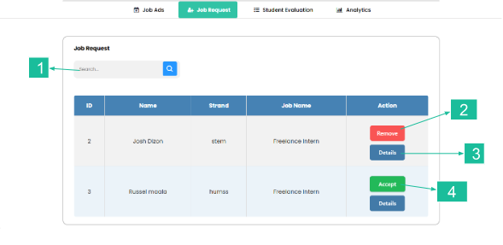**Figure 19: Student Request Form**

|  |  |
| --- | --- |
| **Name of Control** | **Description** |
| **1. Name search bar** | Allows users to enter a specific name to search for corresponding job requests from students. |
| **2. Remove button** | Allows users to cancel their request for applicants applying for their work immersion. |
| **3.Details button** | Allows users to view additional information and specifics related to a particular job request submitted by a student. |
| **4.Accept button** | Used to confirm and approve a specific job request submitted by a student. |

**Name:** Student List Form

**Description:** It Makes It Possible for the Administrators to Evaluate and Monitor Students' Performances by Giving a List of Individuals with Choices of Evaluating the Outputs of Every Student.

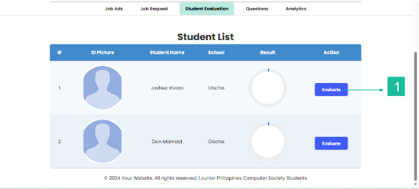

**Figure 19: Student List Form**

|  |  |
| --- | --- |
| **Name of Control** | **Description** |
| **1.Evaluation Button** | Allows administrators to monitor students' performances by evaluating their outputs. |

**Name:** **Company Evaluation Form**

**Description:** Assesses the Student Performance During Work Immersion by Evaluating Criteria Such as Work Habits, Work Skills and Social Skills.

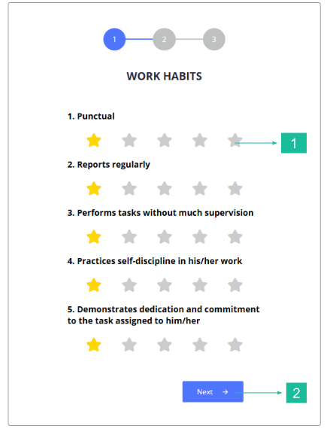

**Figure 20: Company Evaluation Form**

|  |  |
| --- | --- |
| **Name of Control** | **Description** |
| **1. Star rating** | Provide remarks on the performance and conduct of students in their work immersion. |
| **2. Next button** | Enables a user to move onto another page or perform an action or advance in a process. |

**Name:** Student View Profile Form

**Description:** This Displays a List of Students in Different Academic Tracks.

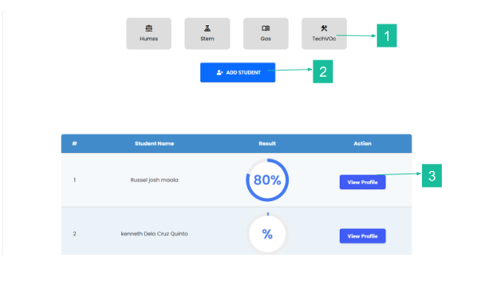**Figure 21: Student View Profile Form**

|  |  |
| --- | --- |
| **Name of Control** | **Description** |
| **1.Strand button** | Allows users to easily view the student profile by selecting a specific strand |
| **2. Add student button** | Allow users to add new students to the evaluation and enable collection of performance assessment of multiple students. |
| **3.View profile button** | Allows users to access detailed information about specific students listed in the table within the "Student View profile form." |

**Name:** Student Report Form

**Description:** This is a List of Students Attached to Other Companies. In This Case, One Can Have a Detailed Report or Archived Records of Every Student.

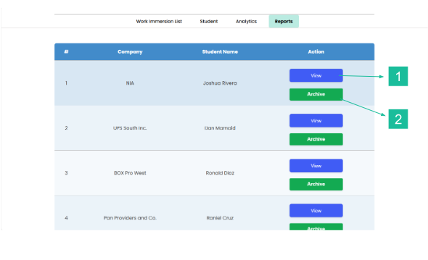

**Figure 22: Student Report Form**

|  |  |
| --- | --- |
| **Name of Control** | **Description** |
| **1.View Button** | Allows users to access detailed information about the students and their respective companies listed in the table. |
| **2.Archive Button** | Allows users to save or store the information of the selected student for future reference. |

**2. Assessment of the developed system based on ISO25010 and the Technology Acceptance Model.**

**2.1 Assessment Based on ISO25010**

The qualities of Workify was assessed by IT professionals using ISO 25010 in terms of functionality, reliability, usability, efficiency, maintainability, portability, security, and compatibility.

**2.1.1 Functionality**

Table 12 shows the result of the assessment made by IT Professionals (IT Instructors & IT Practitioners) on the functionality of the developed system.

|  |  |  |
| --- | --- | --- |
| **Descriptive** | **Mean** | **Verbal Description** |
| Completeness | 4.15 | Very Good |
| Correctness | 3.55 | Very Good |
| Appropriateness | 3.95 | Very Good |
| **Over-All Mean** | **3.88** | **Very Good** |

The table presents the findings of an evaluation performed by IT specialists about the functionality of Workify in accordance with ISO 25010 standards across three criteria: Completeness, Correctness, and Appropriateness. Every criterion attained a mean score corresponding to a qualitative assessment of "**Very Good**". Completeness achieved the highest mean score of **4.15**, indicating that the system proficiently fulfills the needs and expectations of users. The Appropriateness attained a mean score of **3.95**, signifying that the system is proficiently enabling essential operations including task assignment, progress monitoring, student placement, and assessment. The Correctness achieved an average score of **3.55**, signifying that consumers can rely on the system to adequately protect their sensitive information. The average score of **3.88**, classified as '**Very Good**,' signifies that the system fulfills expectations and exhibits efficacy in its overall performance.

A mean score of **3.88** regarding ISO 25010 functionality signifies a predominantly positive evaluation of software quality, especially in terms of functional applicability. This score indicates the software's capacity to fulfill defined requirements and user demands (Lamada et al., 2020). The ISO 25010 standard assesses software quality based on several characteristics, with functional suitability being a vital component that includes completeness, the range of functions offered; correctness, the accuracy of those functions; and appropriateness, the relevance of functions for designated tasks. These properties are crucial for guaranteeing that software satisfies user requirements and operates efficiently within its designated context (Hasana & Rochimah, 2020).

The assessment of Workify's functionality indicates that it operates effectively and fulfills its essential features and user expectations. The functionality qualities attained the "**Very Good**" classification. Nonetheless, the system's functionality requires significant enhancements to elevate its performance and more effectively satisfy quality standards and user requirements.

**2.1.2 Reliability**

Table 13 shows the result of the assessment made by IT Professionals (IT Instructors & IT Practitioners) on the reliability of the developed system.

|  |  |  |
| --- | --- | --- |
| **Descriptive** | **Mean** | **Verbal Description** |
| Accuracy | 3.80 | Very Good |
| Availability | 3.35 | Good |
| Timeliness | 3.60 | Very Good |
| **Over-All Mean** | **3.58** | **Very Good** |

The table displays the results of an assessment conducted by IT specialists about the reliability of Workify in compliance with ISO 25010 standards across three criteria: Accuracy, Availability, and Timeliness. Among the three categories, Accuracy and Timeliness achieved a mean score indicative of a qualitative evaluation of "**Very Good**". Availability received a mean score corresponding to the qualitative assessment "**Good**." The accuracy achieved the highest mean score of **3.80**, indicating that the system exhibits a significant level of precision and dependability in data provision. The timeliness metric achieved a mean score of **3.60**, indicating that the system has regularly exhibited a high degree of promptness and pertinence in delivering notifications and updates regarding open workplaces. The Availability attained an average score of **3.35**, signifying that the system is predominantly stable and accessible, while it may intermittently encounter small challenges requiring resolution. The aggregate mean of **3.58** indicates a rating of "**Very Good**," signifying that the system is reliable and successfully meets user needs.

ISO 25010 defines reliability as a key characteristic of software quality, emphasizing the system's ability to perform its intended functions under specified conditions for a specified period (ISO 25010, n.d.). According to Pratama (2023), the high reliability of ISO 25010 is underscored by its comprehensive framework for evaluating software quality across various dimensions.

Workify's reliability evaluation reveals that it fulfills expectations and exhibits efficacy in the designated area. The reliability attributes attained the "**Very Good**" designation. Nevertheless, the system's reliability indicates that, although it is predominantly dependable, there remain minor areas for enhancement to fulfill expectations and demonstrate efficacy in the designated feature.

**2.1.3 Usability**

Table 14 shows the result of the assessment made by IT Professionals (IT Instructors & IT Practitioners) on the usability of the developed system.

|  |  |  |
| --- | --- | --- |
| **Descriptive** | **Mean** | **Verbal Description** |
| Understandability | 4.10 | Very Good |
| Operability | 3.95 | Very Good |
| Effectiveness | 4.25 | Excellent |
| **Over-All Mean** | **4.10** | **Very Good** |

The table displays the results of an assessment conducted by IT professionals about the usability of Workify, aligned with ISO 25010 standards across three criteria: Understandability, Operability, and Effectiveness. The two criteria, Understandability and Operability, attained a mean score reflecting a qualitative assessment of "**Very Good**." Effectiveness received the highest mean score, corresponding to the qualitative assessment of "Very Good." The Effectiveness attained a mean score of **4.25**, signifying that the system provides a highly effective, user-friendly, and enjoyable experience for users, while demonstrating robust performance in fulfilling their needs. The Understandability indicator attained a mean score of **4.10**, indicating that the system is predominantly user-friendly and comprehensible for both administrators and students. The Operability attained an average score of **3.95**, signifying that the system possesses a commendable user interface that is predominantly user-friendly, featuring clear navigation and intuitive controls. A mean score of **4.10** signifies a "**Very Good**" grade, indicating that the system effectively fulfills user requirements regarding usability.

The average usability score of **4.10**, based on the ISO 25010 framework, signifies a predominantly favorable user experience across many apps. This score indicates the efficacy of usability attributes in improving user satisfaction and operational efficiency (Bimantara & Rochimah, 2023). The ISO 25010 standard delineates fundamental usability attributes, such as understandability, operability, and effectiveness, which are vital for improving user experience in software systems. These attributes guarantee that users can readily understand, maneuver through, and efficiently employ software systems, ultimately resulting in enhanced pleasure and productivity (Surachman, 2024).

The evaluation of Workify's usability demonstrates that it functions efficiently and meets its fundamental features and user expectations. The usability attributes achieved a "Very Good" rating. Despite this outcome, the system requires enhancements to optimize the user experience to the highest degree.

**2.1.4 Efficiency**

Table 15 shows the result of the assessment made by IT Professionals (IT Instructors & IT Practitioners) on the efficiency of the developed system.

|  |  |  |
| --- | --- | --- |
| **Descriptive** | **Mean** | **Verbal Description** |
| Time Behavior | 4.00 | Very Good |
| Capacity | 3.75 | Very Good |
| Resource Utilization | 4.15 | Very Good |
| **Over-All Mean** | **3.75** | **Very Good** |

The table displays the results of an assessment conducted by IT specialists about the efficiency of Workify in alignment with ISO 25010 requirements across three criteria: Time Behavior, Capacity, and Resource Utilization. Each criterion achieved a mean score indicative of a qualitative evaluation of "**Very Good**". Resource Utilization achieved the highest mean score of **4.15**, signifying that the system is effectively optimized for performance, offering users a steady and efficient experience. The Time Behavior aspect attained an average score of **4.00**, indicating a superior degree of performance in responsiveness and system speed. The Capacity attained an average score of **3.75**, suggesting that although there are small areas for enhancement, the system excels in data resource management. The study yielded an overall mean efficiency score of **3.75**, classified as "**Very Good**," signifying that the system is working exceptionally well, albeit there may be slight potential for enhancement.

The evaluation of efficiency in software applications using the ISO 25010 standard reveals significant insights into performance metrics across various platforms. The studies indicate that performance efficiency is a critical characteristic, often assessed through user feedback and technical testing. Achieved a performance efficiency score of **75%** which is equivalent to an overall mean of **3.75**, indicating good performance but highlighting areas for improvement (Rumabar & Maria, 2023).

The evaluation of Workify's efficiency demonstrates that it functions proficiently and meets its fundamental attributes and user expectations. The efficiency attributes achieved the "**Very Good**" designation. The system demonstrates commendable performance; yet it requires additional enhancements for optimal efficacy.

**2.1.5 Maintainability**

Table 16 shows the result of the assessment made by IT Professionals (IT Instructors & IT Practitioners) on the maintainability of the developed system.

|  |  |  |
| --- | --- | --- |
| **Descriptive** | **Mean** | **Verbal Description** |
| Modifiability | 3.85 | Very Good |
| Analyzability | 3.95 | Very Good |
| Reusability | 4.05 | Very Good |
| **Over-All Mean** | **3.95** | **Very Good** |

The table displays the results of an assessment conducted by IT specialists about the maintainability of Workify in alignment with ISO 25010 standards across three criteria: Modifiability, Analyzability, and Reusability. Each criterion achieved a mean score indicative of a qualitative evaluation of "**Very Good**". Reusability attained the highest mean score of **4.05**, indicating that the system is a dependable and versatile solution capable of accommodating its expanding user base while maintaining consistent performance and efficiency. Analyzability achieved a mean score of **3.95**, indicating that the system substantially improves overall maintainability and user experience. Modifiability had a mean score of **3.85**, indicating a strong and flexible codebase for Workify. An average score of **3.95**, categorized as '**Very Good**,' indicates that the system can adeptly manage changes and problems, resulting in improved performance and reduced costs over time.

The ISO 25010 standard characterizes maintainability as an essential software quality property, including sub-characteristics like reusability, analyzability, and modifiability. Although a mean score of **3.95** is encouraging, it is crucial to acknowledge that maintainability might differ markedly among various software projects and environments. Elements like team proficiency and development methodologies can affect the practical maintainability encountered (Irrazabal et al., 2019).

The evaluation of Workify's maintainability demonstrates that it functions efficiently and meets its fundamental functionalities and user requirements. The maintainability attributes achieved a "**Very Good**" rating. Nevertheless, the system's maintainability aligns with expectations and exhibits efficacy in the designated area, yet it requires enhancement to adequately fulfill quality standards and user needs.

**2.1.6 Portability**

Table 17 shows the result of the assessment made by IT Professionals (IT Instructors & IT Practitioners) on the portability of the developed system.

|  |  |  |
| --- | --- | --- |
| **Descriptive** | **Mean** | **Verbal Description** |
| Adaptability | 3.85 | Very Good |
| Replaceability | 4.10 | Very Good |
| Installability | 4.00 | Very Good |
| **Over-All Mean** | **3.98** | **Very Good** |

The table presents the findings of an evaluation performed by IT specialists regarding the portability of Workify in accordance with ISO 25010 standards across three criteria: Adaptability, Replaceability, and Installability. Each criterion attained a mean score corresponding to the qualitative designation '**Very Good**'. Replaceability earned a mean score of **4.10**, signifying that the system excels in innately facilitating flexibility and adaptability for its customers. Installability attained an average score of **4.00**, indicating its compatibility with diverse contexts and mitigating risks linked to hardware or software modifications. Adaptability achieved a mean score of **3.85**, indicating that the system operates across several platforms, reflecting the software's versatility, accessibility, and user-friendliness. A mean score of **3.98**, classified as "**Very Good**," signifies that the system proficiently meets customer demands regarding portability.

Portability, as defined by ISO 25010, includes adaptability, installability, and replaceability, which are essential for software operation in diverse contexts (Britton, 2021). The assessment of Shopeepay's portability, based on ISO 25010, achieved a score of **73.75%**, reflecting a mean score of **3.95**, which signifies a commendable level of portability. This indicates that the application can be efficiently implemented in various situations (Rumabar & Maria, 2023).

Workify's portability evaluation demonstrates its effectiveness and satisfaction of essential features and user expectations. The portability qualities got a "**Very Good**" rating, fulfilling expectations and demonstrating efficacy in the designated area. Nonetheless, the system's potability necessitates substantial enhancements to elevate its performance and more effectively satisfy quality standards and user demands.

**2.1.7 Security**

Table 18 shows the result of the assessment made by IT Professionals (IT Instructors & IT Practitioners) on the security of the developed system.

|  |  |  |
| --- | --- | --- |
| **Descriptive** | **Mean** | **Verbal Description** |
| Confidentiality | 4.10 | Very Good |
| Authenticity | 4.10 | Very Good |
| Accountability | 4.15 | Very Good |
| **Over-All Mean** | **4.12** | **Very Good** |

The table displays the results of an assessment conducted by IT professionals about the security of Workify, aligned with ISO 25010 requirements across three criteria: Confidentiality, Authenticity, and Accountability. Each criterion attained a mean score reflecting a qualitative assessment of "**Very Good**". The table demonstrates that Accountability received the highest mean score of **4.15**, signifying that the system effectively manages and safeguards user data against potential breaches and wrongdoing. The mean score for authenticity was **4.10**, signifying that the system provides a robust framework for managing user access and validating identities. Confidentiality attained an average score of **4.10**, signifying that the system prioritizes user privacy and has implemented substantial safeguards to safeguard personal information. A mean score of **4.12**, classified as "**Very Good**," indicates that the system effectively fulfills the user's security requirements.

The ISO 25010 standard offers a thorough framework for assessing software quality, encompassing security dimensions. A mean score of **4.00** signifies a predominantly positive evaluation of security attributes across diverse information systems. This score indicates the efficacy of security protocols in safeguarding sensitive information and maintaining system integrity (Fadilah & Rochimah, 2023).

Workify's security assessment has yielded a result confirming that the system fulfills expectations and exhibits efficacy in the designated area. The security attributes achieved a "**Very Good**" rating. Nevertheless, Workify's security requires improvement to optimize its performance and better meet quality standards and user expectations.

**2.1.8 Compatibility**

Table 19 shows the result of the assessment made by IT Professionals (IT Instructors & IT Practitioners) on the compatibility of the developed system.

|  |  |  |
| --- | --- | --- |
| **Descriptive** | **Mean** | **Verbal Description** |
| Interoperability | 3.85 | Very Good |
| Co-existence | 4.20 | Excellent |
| Consistency | 4.25 | Excellent |
| **Over-All Mean** | **4.10** | **Very Good** |

The table displays the results of an assessment conducted by IT experts about the compatibility of Workify, in alignment with ISO 25010 standards, across three criteria: Interoperability, Co-existence, and Consistency. The criteria of Co-existence and Consistency attained the highest mean score, signifying a qualitative assessment of "Excellent". Effectiveness achieved a mean score, indicating a qualitative assessment of "Very Good". The attribute of consistency achieved the highest mean score of 4.25, signifying strong confidence in the product's quality and effectiveness. Co-existence achieved an average score of 4.20, signifying that the program promotes a peaceful and reliable operational environment. Interoperability attained a mean score of 3.85, signifying the system's substantial effectiveness in this domain, albeit with some minor limitations. A mean score of 4.10 indicates a "Very Good" rating, implying that the system's compatibility sufficiently fulfills user requirements.

Compatibility in ISO 25010 denotes a software product's capacity to function efficiently across diverse contexts, encompassing multiple hardware, software, and network configurations (ISO 25010, n.d.). Peters & Aggrey (2020) assert that strong compatibility increases user happiness and expands the possible user base, particularly in ERP systems where compatibility is a crucial selection criterion.

The evaluation of Workify's compatibility demonstrates that it functions efficiently and meets its fundamental objectives and user requirements. The compatibility attributes received a "Very Good" rating. Despite the favorable results, the maintainability of Workify necessitates substantial improvements to enhance system compatibility and adequately fulfill quality standards, user requirements, and their experience.

**2.1.9 ISO 25010**

Table 20 shows the result of the assessment of the Workify based on ISO 25010 by IT Professionals (IT Instructors & IT Practitioners).

|  |  |  |
| --- | --- | --- |
| **Descriptors of ISO 25010** | **Over-All Mean** | **Verbal Description** |
| Functionality | 3.88 | Very Good |
| Reliability | 3.58 | Very Good |
| Usability | 4.10 | Very Good |
| Efficiency | 3.97 | Very Good |
| Maintainability | 3.95 | Very Good |
| Portability | 3.98 | Very Good |
| Security | 4.12 | Very Good |
| Compatibility | 4.10 | Very Good |
| **Grand Mean** | **3.96** | **Very Good** |

The table presents the comprehensive outcomes of an evaluation performed by IT specialists utilizing ISO 25010 standards, evaluated across eight criteria: Functionality, Reliability, Usability, Efficiency, Maintainability, Portability, Security, and Compatibility to assess the system's capabilities. Every criterion attained an average score, all of which were classified under the verbal descriptor "Very Good". The criteria of Usability, Compatibility, and Security achieved the highest average means, which ranged from 4.10 to 4.12. The overall mean scores for Reliability, Functionality, Maintainability, Efficiency, and Portability ranged from 3.58 to 3.98. The aggregated mean from each criterion yielded a grand mean of 3.96, indicating that Workify, according to the ISO 25010 evaluation results, exhibits robust performance across the diverse quality attributes specified in the standard's product quality model.

The ISO 25010 quality model enhances systems by offering a standardized framework for assessing software quality. It reduces subjective biases in evaluations, guaranteeing objective assessments based on established product criteria, hence improving software reliability and customer satisfaction (Kashamova, 2021). An approved ISO 25010 outcome signifies a software product's compliance with the quality attributes delineated by the standard, encompassing functionality, reliability, usability, efficiency, maintainability, and portability (Moumane et al., 2024).

The comprehensive evaluation of Workify using ISO 25010 indicated that the system fulfilled expectations and addressed the users' requirements. The overall mean of ISO 25010, recorded at 3.96 and classified as "Very Good," indicates that while the system meets the required level, more modifications are necessary to enhance its acceptability and ensure its endurance.

**2.2 Assessment Based on Technology Acceptance Model**

The user’s acceptance of Workify was assessed by End-Users such as students, teachers, and training supervisors using TAM, which consists of external factors, perceived usefulness, perceived ease of use, attitude towards using, behavioral intention to use, and actual use.

**2.2.1 External Factors**

Table 21 shows the result of the assessment made by End-Users (Students, Teachers, and Training Supervisors) on the external factors of TAM.

|  |  |  |
| --- | --- | --- |
| **Descriptive** | **Mean** | **Verbal Description** |
| Influence | 3.83 | Very Good |
| Implementation | 3.97 | Very Good |
| Effectiveness | 4.13 | Very Good |
| **Over-All Mean** | **3.98** | **Very Good** |

The assessment of Workify, a data analytics-driven solution, was conducted using three criteria: Influence, Implementation, and Effectiveness. Every criterion attained a mean score reflecting a qualitative assessment of "Very Good". The Influence received an average score of 3.83, categorized as “Very Good.” The Implementation attained an average score of 3.97, classified as "Very Good." The Effectiveness attained a mean score of 4.13, signifying a classification of “Very Good”. The system average attained a mean score of 3.98, suggesting that end-users predominantly regard these elements as conducive to the system's adoption.   
 Functional appropriateness, as defined by the ISO 25010 standards, pertains to the degree to which a system or product fulfills its intended purpose by delivering the necessary functionalities demanded by users (ISO/IEC, 2011). This encompasses several critical elements: accuracy, which assesses the system's capability to provide precise and dependable outcomes; comprehensiveness, ensuring the system incorporates all essential functions to achieve user goals; tracking, which evaluates the system's proficiency in monitoring and documenting pertinent activities; and suitability, which examines the extent to which the system's features facilitate task completion. External influences are essential as they affect the system's performance within its environment. The high functional appropriateness of external elements guarantees that a system fulfills user expectations while promoting efficient and effective task execution, hence fostering an atmosphere conducive to overall system adoption and success.   
 The table depicts the External factor of the Workify system, proving its efficacy in reaching its intended aim. Users recognized the system's precision in delivering correct information, its extensive features for dashboard and reporting, and its strong performance in evaluating student outcomes. The overall mean score of 3.98 indicates a strong appreciation for Workify's ability to meet user needs in spotting industry trends. It underscores its robust functionality and importance, demonstrating its efficacy in attaining its goals.

**2.2.2 Perceived Usefulness**

Table 22 shows the result of the assessment made by End-Users (Students, Teachers, and Training Supervisors) on the perceived usefulness of TAM.

|  |  |  |
| --- | --- | --- |
| **Descriptive** | **Mean** | **Verbal Description** |
| Enhancement | 4.10 | Very Good |
| Improvement | 4.00 | Very Good |
| Contribution | 3.93 | Very Good |
| **Over-All Mean** | **4.01** | **Very Good** |

The table evaluates three critical system capabilities: Enhancement, Improvement, and Contribution, employing the Technology Acceptance Model (TAM) to gauge users' perceived usefulness. The mean score of 4.10 for the Enhancement suggests that participants predominantly view the Technology Acceptance Model (TAM) as highly beneficial for improving their duties or activities. The Improvement factor attained a mean score of 4.00, signifying a high level of acknowledgment from participants regarding the beneficial enhancements facilitated by the implementation of TAM. The Contribution attained a mean score of 3.93, signifying a commendable grade, albeit little lower than the other two elements. The system's average score of 4.01, classified as "Very Good," highlights its strong performance and considerable usage patterns across all assessed domains.

The mean for perceived usefulness (PU) in the Technology acceptability Model (TAM) differs among research; nonetheless, a high score typically signifies robust user acceptability. Studies suggest that a PU score of 70% is typically deemed acceptable, with elevated values indicating enhanced perceived advantages of the technology (Ampo & Castro, 2024).   
 The survey results demonstrate that Workify positively influenced the overall enhancement of work immersion program outcomes, achieving a mean score of 4.01, classified as "Very Good." This indicates that Workify significantly contributes to improving student learning experiences and adequately preparing them for future work prospects.

**2.2.3 Perceived Ease of Use**

Table 23 shows the result of the assessment made by End-Users (Students, Teachers, and Training Supervisors) on the perceived ease of use of TAM.

|  |  |  |
| --- | --- | --- |
| **Descriptive** | **Mean** | **Verbal Description** |
| User-friendly | 3.80 | Very Good |
| Effort and Time | 3.77 | Very Good |
| Understandable | 3.70 | Very Good |
| **Over-All Mean** | **3.76** | **Very Good** |

The implementation of Workify, a data analytics-driven solution, was assessed according to three criteria: Usability, Effort and Time, and Comprehensibility. Every criterion attained a mean score reflecting a qualitative assessment of "Very Good". The User-friendly received an average score of 3.80, classified as "Very Good." The Effort and Time attained a mean score of 3.77, classified as "Very Good." Understandable received a commendable mean score of 3.70, categorized as "Very Good." The final score of 3.76, classified as "Very Good," reinforces the favorable assessment of Workify’s user-friendliness.   
 Perceived Ease of Use (PEOU) is a critical component of the Technology Acceptance Model (TAM), which asserts that the greater the ease of technology usage, the higher the likelihood of individual acceptance and utilization. A mean score of 3.76 for PEOU signifies a predominantly favorable view among users, indicating that they consider the technology to be relatively user-friendly. Research suggests that technologies seen as user-friendly foster favorable user perceptions, increase adoption rates, and elevate overall satisfaction (Wicaksono & Maharani, 2020).   
 The perceived ease of use of Workify, as assessed by the Technology Acceptance Model (TAM), yielded results that satisfactorily satisfy expectations and illustrate effectiveness for users. The overall perceived simplicity of use attains a mean score of 3.76, indicating a strong appreciation for Workify's ability to meet user requirements for recognizing industry trends. It underscores its robust functionality and importance, demonstrating its efficacy in attaining its goals.

**2.2.4 Attitude Towards Using**

Table 24 shows the result of the assessment made by End-Users (Students, Teachers, and Training Supervisors) on the attitude towards using TAM.

|  |  |  |
| --- | --- | --- |
| **Descriptive** | **Mean** | **Verbal Description** |
| Beneficial | 3.97 | Very Good |
| Valuable | 3.97 | Very Good |
| Positivity | 3.97 | Very Good |
| **Over-All Mean** | **3.97** | **Very Good** |

The table evaluates three critical system attributes: Beneficial, Valuable, and Positivity, employing the Technology Acceptance Model (TAM) to gauge consumers' perceived utility. Each criterion achieved a mean score of 3.97, classified as "Very Good," signifying that all aspects of attitude towards utilizing the system are satisfactory, fulfill expectations, and exhibit efficacy. The mean ratings for all three criteria items are continuously elevated, averaging 3.97, classified as "Very Good."   
 The favorable perceptions of Workify can be elucidated using the Technology Acceptance Model (TAM), which asserts that perceived ease of use and perceived utility are the principal determinants affecting users' views toward technology. Studies indicate that technologies perceived as easy to use enhance user attitudes, elevate adoption rates, and augment overall happiness (Wicaksono & Maharani, 2020).   
 The attitude towards utilizing Workify, as assessed by the Technology Acceptance Model (TAM), yielded results that satisfactorily fulfill expectations and illustrate efficacy for users. The average score of 3.97 indicates a strong appreciation for Workify's ability to meet user needs in spotting industry trends. It demonstrates efficacy in meeting its aims to be satisfactory to the end-users.

**2.2.5 Behavioral Intention to Use**

Table 25 shows the result of the assessment made by End-Users (Students, Teachers, and Training Supervisors) on the behavioral intention to use of TAM.

|  |  |  |
| --- | --- | --- |
| **Descriptive** | **Mean** | **Verbal Description** |
| Implementation | 3.73 | Very Good |
| Motivation | 3.83 | Very Good |
| Committed | 3.77 | Very Good |
| **Over-All Mean** | **3.78** | **Very Good** |

The assessment of Workify, a data analytics-driven solution, was conducted based on three criteria: Implementation, Motivation, and Commitment. Every criterion attained a mean score reflecting a qualitative assessment of "Very Good". The Implementation attained a score of 3.73, classified as "Very Good". The Motivation obtained score mean is 3.83, classified as "Very Good". The Motivation achieved a score of 3.83, surpassing two criteria also categorized as "Very Good". The Committed received a score of 3.77, the second highest, and is rated as "Very Good." The system's average score of 3.78, categorized as "Very Good," underscores its robust performance and significant usage trends across all evaluated domains.   
 Usage behavior denotes the actual behaviors humans undertake while engaging with technology, reflecting real-world participation. Unlike the intention to use, which focuses on planned actions, usage behavior provides a tangible measure of the frequency and efficacy with which users interact with the system. Intensive usage behavior indicates the effective adoption and incorporation of technology into daily activities, serving as a vital indicator of user satisfaction and system acceptance (Burgess & Worthington, 2021).   
 The behavioral intention to utilize Workify, as per the Technology Acceptance Model (TAM), yielded results that satisfactorily fulfill expectations and exhibit efficacy for users. The average score of 3.78 indicates a strong appreciation for Workify's ability to meet user needs in spotting industry trends. It demonstrates its efficacy in attaining its goals.

**2.2.6 Actual Use**

Table 26 shows the result of the assessment made by End-Users (Students, Teachers, and Training Supervisors) on the actual use of TAM.

|  |  |  |
| --- | --- | --- |
| **Descriptive** | **Mean** | **Verbal Description** |
| Responsive | 3.67 | Very Good |
| Secure | 3.87 | Very Good |
| Opportunity | 3.87 | Very Good |
| **Over-All Mean** | **3.80** | **Very Good** |

The table evaluates three critical system capabilities: Responsive, Secure, and Opportunity, employing the Technology Acceptance Model (TAM) to gauge users' actual use. The Responsive received an average score of 3.67, indicating "Very Good". The Secure attained an average score of 3.87, categorized as "Very Good," reflecting robust user confidence in the platform's capacity to safeguard personal information. The opportunity received an average score of 3.87, categorized as "Very Good," indicating the platform's dedication to user interaction and ongoing enhancement. The system's average score of 3.80, classified as "Very Good," highlights the favorable perception of Workify among its users.

A heightened intention to utilize indicates an increased likelihood of both adoption and continued usage. This intention is generally evaluated by variables such as satisfaction, reliability, usability, commitment, and confidence, which collectively gauge the user's willingness and trust in utilizing the technology. Comprehending the intention to utilize is crucial for evaluating technology acceptability and predicting sustained interaction with the system (Burgess and Worthington, 2021).

The actual use of Workify, as determined by TAM, yielded satisfactory outcomes that align with expectations and exhibit efficacy for users. The aggregate mean score of 3.80 signifies a “Very Good” rating, reflecting Workify's ability to meet user expectations in spotting industry trends. It demonstrates efficacy in attaining its goals.

**2.2.7 Technology Acceptance Model**

Table 27 shows the result of the assessment of the Workify based on TAM by End-Users (Students, Teachers, and Training Supervisors).

|  |  |  |
| --- | --- | --- |
| **Descriptors of TAM** | **Over-All Mean** | **Verbal Description** |
| External Factors | 3.98 | Very Good |
| Perceived Usefulness | 4.01 | Very Good |
| Perceived Ease of Use | 3.76 | Very Good |
| Attitude Towards Using | 3.97 | Very Good |
| Behavioral Intention to Use | 3.78 | Very Good |
| Actual Use | 3.80 | Very Good |
| **Over-All Grand Mean** | **3.88** | **Very Good** |

The table evaluates six critical system capabilities: External Factors, Perceived Usefulness, Perceived Ease of Use, Attitude Towards Using, Behavioral Intention to Use, and Actual Use, employing the Technology Acceptance Model (TAM) to gauge users' perceived utility. External elements obtained a mean score of 3.98 ("Very Good"), signifying that consumers recognize favorable conditions, including institutional support and resources, that facilitate technology uptake. Perceived usefulness had a score of 4.01, indicating "Very Good," which suggests that users believe Workify improves productivity and effectiveness under favorable conditions, including institutional support and resources. The perceived ease of use was graded 3.76, indicating a "Very Good" assessment, which demonstrates a favorable perception of the platform's usability, albeit marginally lower than the perceived usefulness. The attitude towards utilizing Workify received a score of 3.97, categorized as "Very Good," signifying a positive inclination towards the platform that encourages ongoing participation. The behavioral intention to utilize Workify was rated 3.78, indicating "Very Good" and showing that consumers are inclined to persist in its use, as intention is a strong predictor of usage. Ultimately, actual usage received a score of 3.80, categorized as "Very Good," indicating that favorable perceptions are reflected in practical application. An average score of 3.88, categorized as "Very Good," signifies a successful implementation of the technology, demonstrating its efficacy and user-friendliness as assessed by users.

The Technology Acceptance Model (TAM) emphasizes perceived usefulness and perceived ease of use as essential determinants in technology adoption. Elevated scores in these domains signify robust user acceptability and satisfaction, implying that users perceive the system as advantageous and user-friendly, fulfilling their requirements (Burgess & Worthington, 2021). According to the Technology Acceptance Model (TAM), when these qualities receive high ratings, users are more inclined to cultivate favorable attitudes, strengthen their intention to persist in utilizing the technology, and demonstrate consistent usage behavior. The results validate the system's efficacy in meeting user expectations and enhancing engagement (Wicaksono & Maharani, 2020).

The results from the Technology Acceptance Model (TAM) demonstrate that Workify has been favorably received by consumers, indicating significant potential for sustained utilization. Users regard the platform as exceptionally advantageous, enhancing productivity and performance, while also being user-friendly. The system's usability and utility have fostered robust intents for ongoing use, evidenced by users' persistent involvement. The average score of 3.88 indicates substantial satisfaction, aligning with TAM's standards for successful system adoption based on perceived value, usability, and favorable user feedback.

**CHAPTER V**

**SUMMARY, CONCLUSION, AND RECOMMENDATION**

This chapter presents the summary, conclusion, and recommendation of this study.

**Summary**

This study, named "Workify: Streamlining Senior High School Work Immersion Management System with Data Analytics," was made possible by the assistance of the proponent's capstone adviser.

The proponents employed the Scrum Method as the primary method within their developmental framework, encompassing several key phases in the development process: Planning, Design, Development, Testing & Feedback, Iterative Improvements, and Deployment. By utilizing Scrum methodology, the proponents aim to streamline their development process, ensuring high-quality outputs that meet user requirements efficiently.

During the development of the system, the proponents devised a Gantt Chart, as illustrated in Figure 4, to organize the system's development plan. During this phase, the proponents also created various diagrams, such as Data Flow Diagram (DFD) and the Use-Case Diagram, to fully understand and analyze the application's activities and processes, as well as designing the application's User Interface and diagrams such as the Entity Relationship Diagram, Database Normalization, and Data Dictionary.

During the final phase, the proponents presented their system to target end-users and consulted with teachers to get their opinions and feedback that can be used for improving the system.

In this study, the quantitative research approach is utilized to quantify the results of a survey conducted during the evaluation of the constructed system. Proponents used survey questionnaires consistent with the standards of ISO 25010: Functionality, Reusability, Usability, Efficiency, Maintainability, Portability, Security, and Compatibility for 20 IT professionals due to their technical proficiency and familiarity with industry standards; and TAM: External Factors, Perceived Usefulness, Perceived Ease of Use, Attitude Towards Using, Behavioral Intention to Use, and Actual Use for 30 end-users such as students, teachers, and training supervisors tool to gather important information on the acceptance of the Workify. The ratings are as follows: 5 for Excellent, 4 for Very Good, 3 for Good, 2 for Fair, and 1 for Poor.

To analyze the collected data, the proponents utilized Jamovi app for statistical tool.

To present the overall result, the proponents used Table 20 an Table 27 to show the result of the assessment by IT professionals and End-Users of the Workify based on ISO 25010 and TAM, ISO 25010 got an over-all grand mean of 3.96, the TAM got an over-all grand mean of 3.88, both classified as "Very Good," indicates that while the system meets the required level more modifications are necessary to enhance its acceptability and ensure its endurance.

**Conclusion**

Based on the findings, the following conclusions were made:

* The Workify: Streamlining Senior High School Work Immersion Management System with Data Analytics underwent the phases of Scrum Method with the following phases: Planning, Design, Development, Testing & Feedback, Iterative Improvements, and Deployment
* The project aligns with SDG 4 (Quality Education), SDG 8 (Decent Work and Economic Growth), SDG 9 (Industry, Innovation, and Infrastructure), and SDG 17 (Partnerships for the Goals).
* The developed application passed the assessment by selected IT professionals, teachers and students on the ISO 25010.
* An assessment based on the Technology Acceptance Model (TAM) revealed a positive user perception of the system, suggesting that it meets users' needs and encourages active engagement.
* The end-user is willing to accept and willing to use the developed system
* The implementation of data analytics will facilitate accurate matching of students with suitable work placements, standardize performance evaluations, and ensure curriculum relevance to current industry trends

**Recommendation**

The following recommendations were made based on the conclusions and findings of this study.

* The future proponents may improve responsive design for ensuring the website looks great and works properly across all devices.
* The future proponents may improve security to protect the website and the customer.
* The future proponents must have proper communication   
  for a better outcome
* The future proponents must have thorough planning and time management to avoid struggling.
* Future proponents may use graphs and visual aids to help reinforce and provide further information.

**APPENDICES**

**APPENDIX I: Survey Questionnaire Based on ISO 25010 & TAM**

**Workify: Streamlining Senior High School Work Immersion Management System with Data Analytics**

**Name** (Optional):________________________________________

**Direction:** Please evaluate the developed **Workify: Streamlining Senior High School Work Immersion Management System with Data Analytics** based on **ISO 25010**. Use the scale described below.

|  |  |
| --- | --- |
| **Descriptor** | **Scale** |
| There is very strong evidence on the existence of the quality | 5 |
| There is strong evidence on the existence of the quality | 4 |
| There is evidence on the existence of the quality | 3 |
| Some evidence is lacking | 2 |
| There is no evidence | 1 |

|  |  |  |  |  |  |
| --- | --- | --- | --- | --- | --- |
| **Functionality: Refers to the extent to which a system or product fulfills the specified requirements and meets the needs of its users across key aspects such as completeness, correctness, appropriateness, and security.** | **5** | **4** | **3** | **2** | **1** |
| Workify provides all the necessary features and functions required for managing senior high school work immersion. |  |  |  |  |  |
| Workify makes sure that users' data is secure from unauthorized access. |  |  |  |  |  |
| Activities like task assignment, progress tracking, student placement, and evaluation are supported by Workify. |  |  |  |  |  |
| **Reliability: Refers to the system's or product's ability to perform its required functions under stated conditions for a specified period of time.** | **5** | **4** | **3** | **2** | **1** |
| Workify consistently provides accurate and reliable data. |  |  |  |  |  |
| Workify doesn't encounter crashes or system difficulties. |  |  |  |  |  |
| Workify provides notifications and updates regarding available workplaces. |  |  |  |  |  |
| **Usability: Refers to the extent to which specified users can use a system or product to achieve specified goals with effectiveness, efficiency, and satisfaction in a specified context of use.** | **5** | **4** | **3** | **2** | **1** |
| Both administrators and students will find Workify to be simple to understand and use. |  |  |  |  |  |
| Workify has a user-friendly interface with clear navigation and intuitive controls. |  |  |  |  |  |
| Workify facilitates the process of finding suitable workplaces for students. |  |  |  |  |  |
| **Efficiency: Refers to the performance of a system or product concerning the resources used under stated conditions, aiming to maximize the output for a given input or minimize the input for a given output.** | **5** | **4** | **3** | **2** | **1** |
| Workify is responsive in terms of system performance and speed. |  |  |  |  |  |
| Workify handles a large amount of data efficiently without significant delays. |  |  |  |  |  |
| Workify utilize system resources, such as memory and processing power, to optimize performance. |  |  |  |  |  |
| **Maintainability: Refers to the system's or product's ability to be modified and adapted to changes in the environment, requirements, or functional specifications with a specified effort.** | **5** | **4** | **3** | **2** | **1** |
| It is easy to maintain and update the codebase of the Workify website. |  |  |  |  |  |
| Workify is documented, making it easier for developers and administrators to understand and maintain the system. |  |  |  |  |  |
| Workify accommodates growth well and handles increasing workloads over time. |  |  |  |  |  |
| **Portability: Refers to the ability of a system or product to be transferred from one environment, platform, or context of use to another, with minimal or no adaptation required.** | **5** | **4** | **3** | **2** | **1** |
| Workify function across different platforms. |  |  |  |  |  |
| Workify's data can be transferred or migrated to different environments or systems. |  |  |  |  |  |
| Workify is not dependent on specific hardware or software configurations. |  |  |  |  |  |
| **Security: Refers to the system's or product's ability to protect information and data from unauthorized access, disclosure, disruption, modification, or destruction, ensuring confidentiality, integrity, and availability.** | **5** | **4** | **3** | **2** | **1** |
| Workify ensures the security and protection of user data from unauthorized access or breaches. |  |  |  |  |  |
| Workify effectively authenticate users and control access to sensitive features and data. |  |  |  |  |  |
| Workify handles and protects user privacy, ensuring compliance with relevant regulations. |  |  |  |  |  |
| **Compatibility: refers to the ability of a system or product to function and interact seamlessly with other systems or products, without requiring special effort on the part of the user.** | **5** | **4** | **3** | **2** | **1** |
| Workify integrates and interacts with other systems, APIs, or protocols. |  |  |  |  |  |
| Workify exchanges data with external systems, ensuring compatibility and consistency. |  |  |  |  |  |
| Workify functions across different web browsers, ensuring consistent user experience and functionality. |  |  |  |  |  |

**Workify: Streamlining Senior High School Work Immersion Management System with Data Analytics**

**Name** (Optional):________________________________________

**Direction:** Please evaluate the developed **Workify: Streamlining Senior High School Work Immersion Management System with Data Analytics** based on the **Technology Acceptance Model (TAM)**. Use the scale described below.

|  |  |
| --- | --- |
| **Descriptor** | **Scale** |
| There is very strong evidence on the existence of the quality | 5 |
| There is strong evidence on the existence of the quality | 4 |
| There is evidence on the existence of the quality | 3 |
| Some evidence is lacking | 2 |
| There is no evidence | 1 |

|  |  |  |  |  |  |
| --- | --- | --- | --- | --- | --- |
| **External: Refer to factors outside of the model that can influence a user's perceived usefulness and perceived ease of use of a technology, which in turn affect the user's attitude and intention to use the technology.** | **5** | **4** | **3** | **2** | **1** |
| The support and endorsement of educational institutions and authorities would positively influence adopting a data analytics-driven Work Immersion Management System. |  |  |  |  |  |
| The availability of resources and infrastructure to implement a data analytics-driven system would impact its adoption. |  |  |  |  |  |
| The collaboration and involvement of industry partners and organizations would enhance the effectiveness of the data analytics-driven system. |  |  |  |  |  |
| **Perceived Usefulness: Refers to the degree to which a user believes that using a particular technology or system will enhance their job performance or productivity.** | **5** | **4** | **3** | **2** | **1** |
| Workify would enhance the efficiency of managing senior high school work immersion programs. |  |  |  |  |  |
| Workify would improve the accuracy and reliability of data analysis for work immersion activities. |  |  |  |  |  |
| Workify would contribute to the overall improvement of work immersion program outcomes. |  |  |  |  |  |
| **Perceived Ease of Use: Refers to the degree to which a user believes that using a particular technology or system will be free of effort.** | **5** | **4** | **3** | **2** | **1** |
| The user interface of Workify is intuitive and user-friendly. |  |  |  |  |  |
| Using Workify would require minimal effort and time. |  |  |  |  |  |
| Workify is easy to learn and understand. |  |  |  |  |  |
| **Attitude Towards Using: Refers to the user's overall attitude or evaluation of using a particular technology or system, which is influenced by both perceived usefulness and perceived ease of use.** | **5** | **4** | **3** | **2** | **1** |
| Using Workify would be beneficial for the management of senior high school work immersion. |  |  |  |  |  |
| I perceive Workify as a valuable tool for enhancing work immersion program effectiveness. |  |  |  |  |  |
| I have a positive attitude towards using Workify in my work. |  |  |  |  |  |
| **Behavioral Intention to Use: Refers to the strength of a user's intention to use a particular technology or system, which is influenced by their attitude towards using and perceived usefulness of the technology.** | **5** | **4** | **3** | **2** | **1** |
| I intend to use Workify for managing senior high school work immersion programs in the future. |  |  |  |  |  |
| I am motivated to use Workify in my daily work activities. |  |  |  |  |  |
| I see myself using Workify regularly for work immersion management tasks. |  |  |  |  |  |
| **Actual Use: Refers to the user's real-world usage behavior or adoption of a particular technology or system, which is determined by their behavioral intention to use.** | **5** | **4** | **3** | **2** | **1** |
| Workify is responsive and did it load quickly, without any significant delays. |  |  |  |  |  |
| Workify is safe to use because it ensures that personal information is retained and data is protected. |  |  |  |  |  |
| Workify gives an opportunity to provide feedback or report issues to the user experience. |  |  |  |  |  |

**APPENDIX II: Screenshots of Statistical Treatment Using JAMOVI**

**ISO 25010**

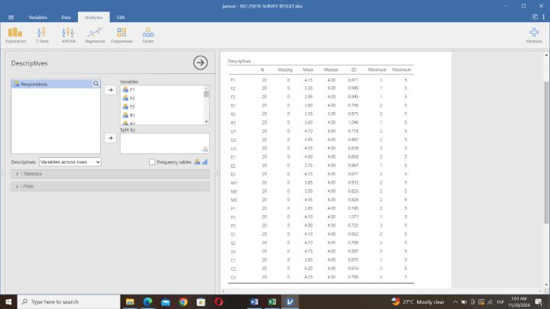

**ISO 25010 Cronbach’s Alpha**

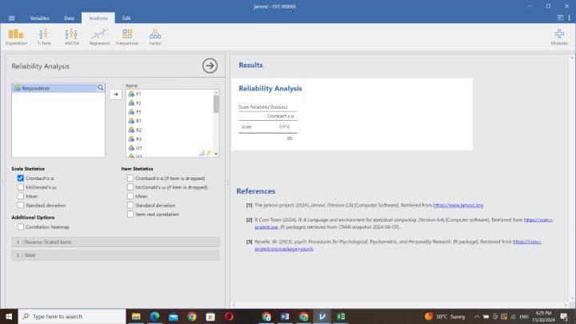

**TAM**

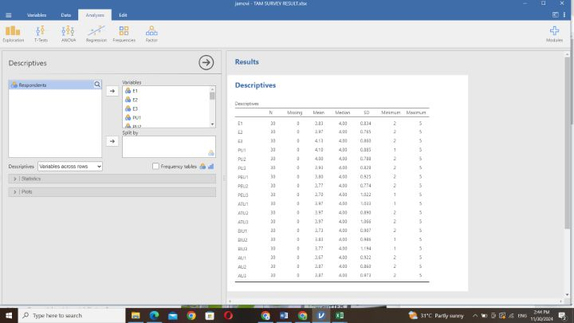

**TAM Cronbach’s Alpha**

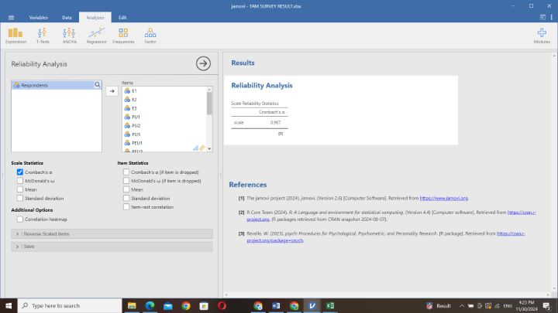

**References**

5 Easy Tips for Streamlining Business Processes at Your Company. (2024). Retrieved from kissflow.com website: https://kissflow.com/workflow/bpm/business-process-automation/streamlining-business-process/#:~:text=Streamlining%20processes%20refers%20to%20the

A Glimpse of the Past-and the Present. (2023). *The Australasian Journal of Optometry*, *10*(11), XIV–XV. https://doi.org/10.1111/j.1444-0938.1929.tb02130.x

Acut, D. P., Curaraton, E. P., Latonio, G. C., & Latonio, R. A. C. (2021). Work immersion performance appraisal and evaluation of Grade 12 STEM students in science and technology-based industries. *Journal of Physics: Conference Series*, *1835*(1), 012013. <https://doi.org/10.1088/1742-6596/1835/1/012013>

Ador, Z. I., Banaag, H. A. C., Bombio, C. A. M., Consignado, D. N. A., Quinay, M. A. V., & Santos, J. L. C. (2023). Exploring the Work Immersion Experiences of Grade 12 STEM Students in a Local Science Integrated High School: A Narrative Research. *East Asian Journal of Multidisciplinary Research*, *2*(7), 3053–3078. <https://doi.org/10.55927/eajmr.v2i7.4989>

Adjust. (n.d.). What is a Dashboard? How Adjust displays your data | Adjust. Retrieved from www.adjust.com website: <https://www.adjust.com/glossary/dashboard/>

Afiifah, K., Azzahra, Z. F., & Anggoro, A. D. (2022). Analisis Teknik Entity-Relationship Diagram dalam Perancangan Database Sebuah Literature Review. *INTECH*, *3*(2), 18–22. https://doi.org/10.54895/intech.v3i2.1682

Ahmed Alnagrat, A. J., Ahmed, K. M. S., Alkhallas, M. I., Almakhzoom, O. A. I., Syed Idrus, S. Z., & Che Ismail, R. (2023, May 1). Virtual Laboratory Learning Experience in Engineering: An Extended Technology Acceptance Model (TAM). <https://doi.org/10.1109/MI-STA57575.2023.10169123>

Al Rahmad, A. H., Ichsan, I., & Wilis, R. (2023). Implementation of Android Platform Application “PSG Balita” ISO/IEC 25010 Standardized to Improve Nutritional Status Data for Toddler. Poltekita: Jurnal Ilmu Kesehatan - Vol. 17, Iss: 1, pp 14-21.

Alcobendas, J. R. (2022). Profile and Work Immersion Performance of Accountancy, Business, and Man-agement (ABM) students of selected implementing schools in Subic District, Zambales, Philippines. International Journal of Multidisciplinary, 3(4). https://doi.org/10.11594/ijmaber.03.04.05.

Altvater, A. (2024, February 28). What is SDLC? Understand the Software Development Life Cycle. Retrieved from Stackify website: <https://stackify.com/what-is-sdlc/>

Alzahrani, A. (2023). An analysis of the Technology Acceptance Model TAM in understanding Faculty’s behavioral intention to use Internet of Things IOT. *IJERI: International Journal of Educational Research and Innovation*, (19), 153–169. <https://doi.org/10.46661/ijeri.7461>

Amper, E. C. (2022). Exploring the Experiences of Senior High School Students on Business Simulation in the New Normal: Basis for a Proposed Intervention Program. *International Journal of Multidisciplinary: Applied Business and Education Research*, *3*(2), 180–203. <https://doi.org/10.11594/ijmaber.03.02.06>

Ampo, M. V., & Castro, J. (2024). View of Technology Acceptance Model (TAM) - Based Assessment of User Acceptance for a Smart Crop Management System. Retrieved from Uplb.edu.ph website: <https://ovcre.uplb.edu.ph/journals-uplb/index.php/PJABE/article/view/1181/935>

Analyzing the effectiveness of different testing techniques in ensuring software quality. (2023). *Typeset.io*. <https://doi.org/10.22541/au.168311906.69859824/v1>

ANN, MA. (2023). WORK IMMERSION IN BLENDED LEARNING MODALITY ON THE SATISFACTION AND PERFORMANCE OF SENIOR HIGH SCHOOL GRADUATES OF STA. CATALINA INTEGRATED NATIONAL HIGH SCHOOL. *International Journal of Research Publications*, *124*(1). <https://doi.org/10.47119/ijrp1001241520234924>

Arceta, M. A. C. C. (2023). WORK IMMERSION IN BLENDED LEARNING MODALITY ON THE SATISFACTION AND PERFORMANCE OF SENIOR HIGH SCHOOL GRADUATES OF STA. CATALINA INTEGRATED NATIONAL HIGH SCHOOL. International Journal of Research Publications. <https://doi.org/10.47119/ijrp1001241520234924.https://typeset.io/papers/work-immersion-in-blended-learning-modality-on-the-2b4xjld1>.

Bagas Pratama. (2023). Analysis of Livin’ By Mandiri Application Quality With Iso 25010 Method. *Jurnal Teknologi Informasi Dan Pendidikan*, *16*(2), 244–254. <https://doi.org/10.24036/jtip.v16i2.789>

Barney, N. (2023, January 1). What is stakeholder? - Definition from WhatIs.com. Retrieved from SearchCIO website: <https://www.techtarget.com/searchcio/definition/stakeholder>

Bianconi, F. (2024). Gantt Charts. *Data and Process Visualisation for Graphic*  *Communication*, 175–181. <https://doi.org/10.1007/978-3-031-57051-3_13>

Bimantara, I. M. S., & Rochimah, S. (2023). Usability Characteristics Evaluation on Food Delivery Service Applications using ISO/IEC 25010 Quality Model. *2023 14th International Conference on Information & Communication Technology and System (ICTS)*, 1–6. <https://doi.org/10.1109/icts58770.2023.10330853>

Bithia Rumabar, & Maria, E. (2023). Evaluasi Kualitas Shopeepay Menggunakan ISO/IEC 25010. *Jurnal Sistem Informasi Bisnis*, *14*(1), 54–61. <https://doi.org/10.21456/vol14iss1pp54-61>

Business Jargons. (2017, July 1). Organization. Retrieved from Business Jargons website: <https://businessjargons.com/organization.html>

Buzhinskaya, N. V., & Vaseva, E. S. (2022). CREATING A BACKLOG OF A SOFTWARE PRODUCT AS A METHOD OF PREPARING A FUTURE IT SPECIALIST FOR PROFESSIONAL ACTIVITIES. *Vestnik Altaiskogo Gosudarstvennogo Pedagogiceskogo Universiteta*, (51), 33–38. <https://doi.org/10.37386/2413-4481-2022-2-33-38>

Britton, J. (2021, May 6). What Is ISO 25010? Retrieved from Perforce Software website: <https://www.perforce.com/blog/qac/what-is-iso-25010>

Byung-Kwon, J. (2003). Development and application of a model for analysis and design phases of Web-based system development. *Science in China Series F*, *46*(4), 241. <https://doi.org/10.1360/02yf0058>

Casey, J. D., Courtright, K. R., Rice, T. W., & Semler, M. W. (2021a). What can a learning healthcare system teach us about improving outcomes? *Current Opinion in Critical Care*, *27*(5), 527–536. https://doi.org/10.1097/MCC.0000000000000857

Cassar, C. (2022). Addressing Transformative Education and Governance Through the Sustainable Development Goal 4: A Case Study. *Opportunities and Challenges in Sustainability*, *1*(2), 105–115. <https://doi.org/10.56578/ocs010203>

Davis, W. S. (2019). Data flow diagrams. *The Information System Consultant’s Handbook*, 175–188. https://doi.org/10.1201/9781420049107-24

Dela Cruz, J. (2020). Workplace Skills and Competencies: An Industry Partners Appraisal on Work Immersion Program Among Senior High School Learners. *Typeset.io*, *2*(3), 41–48. Retrieved from <https://typeset.io/papers/workplace-skills-and-competencies-an-industry-partners-22145573yj>

Donhost, M. J., & Anfara, V. A. (2010). Data-Driven Decision Making. *Middle School Journal*, *42*(2), 56–63. <https://doi.org/10.1080/00940771.2010.11461758>

Definition of technologies | Dictionary.com. (2019). Retrieved from www.dictionary.com website: <https://www.dictionary.com/browse/technologies>

Dewantara, K. W., Piarsa, I. N., & Buana, P. W. (2019). Website-based high school management information system. International Journal of Computer Applications Technology and Research, 8(11), 420-424. <https://doi.org/10.7753/ijcatr0811.1003>.

Duz, B. (2023). *Data-Based Decision-Making (DBDM) in Education*. Retrieved from <https://repository.library.northeastern.edu/files/neu:4f21nx20q/fulltext.pdf>

Florist, A. (2023). Deployment. *Typeset.io*, 321–345. <https://doi.org/10.1007/978-1-4842-9256-3_12>

Franco, A., Olah, B., Sass, Z., Hegedüs, C., & Varga, P. (2022, May 24). Towards CBDC-supported Smart Contracts for Industrial Stakeholders. <https://doi.org/10.1109/icps51978.2022.9816857>

Frankenfield, J. (2023). What Is Business Intelligence (BI)? Types, Benefits, and Examples. Retrieved March 19, 2024, from Investopedia website: <https://www.investopedia.com/terms/b/business-intelligence-bi.asp#:~:text=Data%20analytics%20is%20the%20science>

Gaftandzhieva, S., Docheva , M., & Doneva, R. (2021). “A comprehensive approach to learning analytics in Bulgarian school education”, Education and Information Technologies.

Garcia, A., & Yazon, A. (2020). work immersion performance, alignment, and employability among senior high school graduates. International Journal of Advanced Research, 8(5), 552-564. <https://doi.org/10.21474/ijar01/10960>.

Gelu, P., Sarno, R., & Siahaan, D. (2018). Requirements Association Extraction based on Use Cases Diagram. *Lontar Komputer : Jurnal Ilmiah Teknologi Informasi*, 11. <https://doi.org/10.24843/lkjiti.2018.v09.i01.p02>

Gera, R., Chadha, P., Pandey, A. K., Kampani, S., Dixit, S., Tummala, S. K., & Gâtea, M. (2023). A narrative review on use of biomaterials in achieving SDG 9: Build resilient infrastructure, promote sustainable industrialization and foster innovation. - Vol. 391, pp 01180-01180.

Gordon, E., Schirra, S., & Hollander, J. (2011). Immersive Planning: A Conceptual Model for Designing Public Participation with New Technologies. *Environment and Planning B: Planning and Design*, *38*(3), 505–519. <https://doi.org/10.1068/b37013>

Gurobat, P. M. N., & Lumbu-an, J. D. (2022). Challenges Encountered in the Implementation of the Education Program among Senior High School Students in The Philippines. *Indonesian Journal of Educational Research and Technology*, *2*(1), 65–70. <https://doi.org/10.17509/ijert.v2i1.41225>

Hariman Surya Siregar. (2023). Perceived Usefulness and Perceived Ease of Use of Online Learning for Islamic Religious Education Teacher. *JPI (Jurnal Pendidikan Islam)*, *9*(1), 93–106. <https://doi.org/10.15575/jpi.v0i0.25518>

Hasanah, N. A., Atikah, L., & Rochimah, S. (2020, September 1). Functional Suitability Measurement Based on ISO/IEC 25010 for e-Commerce Website. <https://doi.org/10.1109/ICITACEE50144.2020.9239194>

IBM. (2023, May 22). Defining the boundaries of a system. Retrieved from www.ibm.com website: https://www.ibm.com/docs/en/dma?topic=diagrams-defining-boundaries-system

Ibrahim, A., & Shiring, E. (2022). The Relationship between Educators’ Attitudes, Perceived Usefulness, and Perceived Ease of Use of Instructional and Web-Based Technologies: Implications from Technology Acceptance Model (TAM). *International Journal of Technology in Education*, *5*(4), 535–551. <https://doi.org/10.46328/ijte.285>

Insorio, A. O., Manaloto, C. C., & Lareña, J. J. (2023). Building awareness, interest, and readiness towards college course through work immersion. *Mediterranean Journal of Social & Behavioral Research*, *7*(2), 65–74. <https://doi.org/10.30935/mjosbr/12808>

ISO 25010. (n.d.). Retrieved from iso25000.com website: <https://iso25000.com/index.php/en/iso-25000-standards/iso-25010?start=5>

K-12 Basic Education Curriculum| K12 Philippines. (2015, October 27). Retrieved from K12philippines website: <https://k12philippines.com/>

Koelsch, G. (2023). Use Cases. *Apress EBooks*, 433–461. <https://doi.org/10.1007/978-1-4842-9830-5_14>

Kumar, P. P., Ch. Satyanarayana, Rao, A. A., & Raju, P. R. (2016). *Task Reprocessing on Real-Time Multicore Systems*. <https://doi.org/10.1145/2980258.2980460>

Lindsay, A., Maguigad, N., Petkov, M., Trigere, S. Z., & Young, B. (2015, April 24). System and method for streamlining the design and development process of multiple advertising units. Retrieved May 8, 2024, from typeset.io website: https://typeset.io/papers/system-and-method-for-streamlining-the-design-and-4el2936bud

Little, T. D., Stickley, Z. L., Rioux, C., & Wu, W. (2024, January 1). Quantitative Research Methods. Retrieved from ScienceDirect website: <https://www.sciencedirect.com/science/article/abs/pii/B9780323960236000956?via%3Dihub>

Liu, Y., Liang, Z., Li, C., Guo, J., & Zhao, G. (2022). An Investigation into the Adoption Behavior of mHealth Users: From the Perspective of the Push-Pull-Mooring Framework. *Sustainability*, *14*(21), 14372. <https://doi.org/10.3390/su142114372>

LucidChart. (2017). ER Diagram Tutorial. Retrieved from Lucidchart website: <https://www.lucidchart.com/pages/er-diagrams>

Macalintal, I., & Chavez, C. D. (2020). Assessing the Senior High School Work Immersion with Partner Industries: Basis for Supervisory Work Plan. JPAIR Multidisciplinary Research.

Malapane, T. A., & Ndlovu, N. K. (2024). Assessing the Reliability of Likert Scale Statements in an E-Commerce Quantitative Study: A Cronbach Alpha Analysis Using SPSS Statistics. *Assessing the Reliability of Likert Scale Statements in an E-Commerce Quantitative Study: A Cronbach Alpha Analysis Using SPSS Statistics*. https://doi.org/10.1109/sieds61124.2024.10534753

Manan, W. D. B. W. A., Wahab, Z. I. A., Mahmud, S. H., & Yusof, N. M. (2022). An instrument to Measure the Use of Electronic Communication Channels with MTAM. - pp 52-57.

Manayan, M. B. (2022). Influence of Industry Experts’ Technical Assistance to the Students’ Job Satisfaction and Performance in Work Immersion on the Senior High Schools in Zamboanga City: A Quantitative Analysis. IOER International Multidisciplinary Research Journal (Online). <https://doi.org/10.54476/iimrj19>.

McKinsey. (2022, August 17). What is innovation? | McKinsey. Retrieved from www.mckinsey.com website: <https://www.mckinsey.com/featured-insights/mckinsey-explainers/what-is-innovation>

Mendoza, D., & Piedra, N. (2020). TutNorBD: Assistant for teaching and learning process of relational database normalization up to 3NF from a universal table. *2020 XV*  *Conferencia Latinoamericana de Tecnologias de Aprendizaje (LACLO)*. <https://doi.org/10.1109/laclo50806.2020.9381184>

Muhammad Darmawan Fadilah, & Siti Rochimah. (2023). *Security Evaluation of Insurance Portal Agency Information System Based on ISO/IEC 25010 Quality Standard Utilizing OWASP ZAP*. <https://doi.org/10.1109/icicyta60173.2023.10428701>

Neil. (2019, February 12). Jarke & Breiter (2019) on the datafication of education. Retrieved May 16, 2024, from enhancing the use of digital data in secondary schools website: <https://data-smart-schools.net/2019/02/13/jarke-breiter-2019-on-the-datafication-of-education/?fbclid=IwZXh0bgNhZW0CMTAAAR17muUe3ODMPIRUnEOVR120-sh7tt0YEchppRO_yyFdbnvWcMRS4jp8_4U_aem_AQeYHzkvM5mSdoU_EmxjNQQvZ6Axjq7ErIOvp8JFWQ1zlyONjpp_6P2gnTFZuCiZVX4BeXGVExlEdlHICvAAAhgc>

Patero, J. L. (2023). Streamlining Physics Laboratory Management: An Information System Solution. *International Journal of Advanced Research in Science, Communication and Technology*, *3*(1), 796–801. <https://doi.org/10.48175/ijarsct-12373>

Pfeiffer, J., Fegert, J., Greif-Winzrieth, A., Hoffmann, G., & Peukert, C. (2021). Can Immersive Systems Help Address Sustainability Goals? Insights from Research in Information Systems. *Typeset.io*, 135–150. <https://doi.org/10.1007/978-3-030-66661-3_8>

Rae Yule Kim. (2023). Data-Driven User Experience Design. *Interactions*, *30*(4), 56–58. <https://doi.org/10.1145/3603717>

Rahmana, Y., & Indriani, M. (2022). SI APIK Application User Satisfaction with The TAM and Delone and Mclean Approach: An Empirical Study on Micro, Small and Medium Enterprises (MSME) in Banda Aceh. *Jurnal Akuntansi*, *12*(1), 23–36. <https://doi.org/10.33369/j.akuntansi.12.1.23-36>

Raubenolt, A. (2016). *An Analysis of Collaborative Problem-Solving Mechanisms in Sponsored Projects: Applying the 5-Day Sprint Model*. Retrieved from <https://files.eric.ed.gov/fulltext/EJ1152255.pdf>

Rydhan Bawara, Andree Sulistya Saputra, Ardi Widyanto Saputra, & Teguh Prasandy. (2023). *Evaluation of User Acceptance on the Lemihealth Digital Platform Using the Technology Acceptance Model (TAM) Method*. <https://doi.org/10.1109/icbir57571.2023.10147617>

Salahudin, S., Syamsulrizal, S., & Prakoso, H. A. (2023). The Economic Development of Asian Countries With Achievement of SDG 8: A Systematic Literature Review - Vol. 13, Iss: 1, pp 92-105.

Seidl, M., Scholz, M., Huemer, C., & Kappel, G. (2015). The Use Case Diagram. *UML @ Classroom*, 23–47. <https://doi.org/10.1007/978-3-319-12742-2_3>

Sethi, N., & Malhotra, A. (2023). Efficiency Engine: Designing and Implementing an Academic Management System. *International Journal of Innovative Research in Engineering and Management*. https://doi.org/10.55524/ijirem.2023.10.3.15

Shahrestani, A., & Gorp, P. V. (2016). GameBus Pilot Studies (5): Internal Consistency Reliability - Chronbach’s Alpha. *Figshare*. <https://doi.org/10.6084/u002Fm9.figshare.4038447.v2>

Sidek, M. R. E. B., Impil, J. A. D., Marcos, M. J. B., Punzalan, E. E. M., Ramos, J. T., & Ador, Z. I. (2023). Exploring Course Mismatch among Former STEM Students: A Narrative Research. *Cognizance Journal of Multidisciplinary Studies*, *3*(7), 78–90. <https://doi.org/10.47760/cognizance.2023.v03i07.008>

Singh, A. P. (2023). A STUDY ON IMPACT OF SOCIAL MEDIA ON RECRUITMENT PROCESS. *INTERANTIONAL JOURNAL of SCIENTIFIC RESEARCH in ENGINEERING and MANAGEMENT*, *07*(04). <https://doi.org/10.55041/ijsrem18787>

Solehatin Ika Putri, Affifatusholihah, L., & Putri, F. (2023). Theory Acceptance Model (TAM) untuk Mengukur Minat Wanita dalam Mengikuti Pelatihan Prakerja. *Jurnal Manajemen Dan Sains*, *8*(1), 302–302. <https://doi.org/10.33087/jmas.v8i1.989>

Soncin, M., & Cannistrà, M. (2021). Data analytics in education: are schools on the long and winding road? Qualitative Research in Accounting &Amp; Management, 19(3), 286-304. <https://www.emerald.com/insight/content/doi/10.1108/QRAM-04-2021-0058/full/html>.

Song, C. (2015). *The Requirement Analysis of Software based on Use Case Modeling*. <https://doi.org/10.2991/ssemse-15.2015.198>

Surachman, A. (2024). Optimasi Pengalaman Pengguna: Evaluasi ISO/IEC 25010 pada Penjualan Online. *STRING (Satuan Tulisan Riset Dan Inovasi Teknologi)*, *8*(3), 286–286. <https://doi.org/10.30998/string.v8i3.19324>

Tam, T., & Lee, Y. J. (2022). Building improvised microbial fuel cells: A model integrated STEM curriculum for middle-school learners in Singapore. Education Sciences, 12(6), 417.

Tang, Y. W., Toh, S., & Leow, A. S. (2022). Dashboards for Decision Making in Higher Education. *ASCILITE Publications*, 321–329. <https://doi.org/10.14742/apubs.2019.279>

The Role of Attitude in Mediating the Influence of Perceived Usefulness on Intention to Use Nagari Mobile Banking. (2023). *Journal of Economics, Finance and Management Studies*, *06*(05). <https://doi.org/10.47191/jefms/v6-i5-02>

Trichkova-Kashamova, E. (2021, May 1). Applying the ISO/IEC 25010 Quality Models to an Assessment Approach for Information Systems. <https://doi.org/10.1109/ELECTRONICA52725.2021.9513662>

UC Merced Library. (2023). What Is a Data Dictionary? | UC Merced Library. Retrieved from library.ucmerced.edu website: https://library.ucmerced.edu/data-dictionaries

Vaghar, S., Wyatt-Buchan, S., Dayal, S., Banik, S., & Nahar, A. (2023). The Power of Intergenerational Partnership: Students, Universities, and SDG17. Retrieved from <https://www.emerald.com/insight/content/doi/10.1108/978-1-80455-704-420231006/full/html>

Verma, S. K. (2022). Role of Management Information Systems in Education Sector. *Amity Journal of Professional Practices*, *2*(01). <https://doi.org/10.55054/ajpp.v2i01.633>

<https://doi.org/10.1108/09576050010306387>

Wai-Sing, L. (2018). Method and system for learning programme outcomes management. *Typeset.io*. Retrieved from <https://typeset.io/papers/method-and-system-for-learning-programme-outcomes-management-14kbb1665o>

What is a database? (2020). Retrieved from Oracle.com website: <https://www.oracle.com/ph/database/what-is-database/>

What is Software? Definition, Types, and Examples | Simplilearn. (2022, October 26). Retrieved from Simplilearn.com website: <https://www.simplilearn.com/tutorials/programming-tutorial/what-is-software#:~:text=The%20software%20can%20be%20best>

Wicaksono, A., & Maharani, A. (2020). The influence of perceived ease of use and perceived usefulness on the intention to use e-learning. International Journal of Emerging Technologies in Learning (iJET), 15(12), 4-16. <https://doi.org/10.3991/ijet.v15i12.13473>

Yadav, K., Pandey, M., & Siddharth Swarup Rautaray. (2017). A proposed framework for feedback analysis system using big data tools. *2017 International Conference on I-SMAC (IoT in Social, Mobile, Analytics and Cloud) (I-SMAC)*. <https://doi.org/10.1109/i-smac.2017.8058238>

Yasmin, S. (2019). What is work immersion? Why is it important? Retrieved March 19, 2024, from Quora website: <https://www.quora.com/What-is-work-immersion-Why-is-it-important>

York, R. O. (2022, November 15). Quantitative methods for mental health research. Retrieved from www.elgaronline.com website: <https://www.elgaronline.com/edcollchap/book/9781800372788/book-part-9781800372788-13.xml>

Zakariya, Y. F. (2022). Cronbach’s alpha in mathematics education research: Its appropriateness, overuse, and alternatives in estimating scale reliability. *Frontiers in Psychology*, *13*. <https://doi.org/10.3389/fpsyg.2022.1074430>

Zhang, Y., & Zhao, X. (2015). "Interoperability in Cloud Computing: A Survey." Journal of Cloud Computing: Advances, Systems and Applications, 4(1), 1-12.

Smith, J., & Lee, K. (2016). "The Role of Compatibility in Software Development: A Systematic Review." Software Engineering Journal, 29(3), 123-145.

Johnson, R., & Wang, T. (2018). "Evaluating the Co-existence of Legacy Systems in Modern IT Environments." International Journal of Information Management, 38(1), 45-56.

Brown, A., & Green, T. (2019). "User Experience Consistency Across Platforms: Challenges and Solutions." Journal of Usability Studies, 14(2), 75-90.